
Stop Smoking London has created a guide on how to quit smoking for good
Stop Smoking London is encouraging people to make a quit attempt this Stoptober and has created ‘A Practical Guide for Londoners on how to quit smoking’, featuring hints and tips from experts.
The guide includes a one-page printable ‘Tips Directory’ to help deal with the most common triggers and cravings.
The guide is available for download on the Stop Smoking London website: www.stopsmokinglondon.com/stoptober

Help us spread the word with your residents
We’ve pulled together a range of assets including social media posts, a video and web copy to help you share the guide with your residents.

Poster to signpost smokers to free support in London
You can download an editable A4 poster to provide your audiences with information on where to go to find services within their borough, digital tools, as well as Stop Smoking London’s telephone quit programme and text message service.
Adaptable digital poster
Please use the following link to access a generic digital poster that you can adapt to suit your needs. Simply click on the link and open in Word, you can then add your own logo in the top, right hand corner and add your own copy where lorem ipsum text is displayed, for example highlight a clinic time/location or referral/contact details. It’s a poster that you can tailor to suit your needs and can be shared digitally or printed out and displayed.

If you do not have access to Word, please contact joannam@gardiner-richardson.com and we can send an alternative format.

Social media posts
Download graphics illustrated below to use on social media with these pre-written posts.
Stop Smoking London is @StopSmokingLDN on X (Twitter) and @StopSmokingLondon on Facebook. Join the conversation online using these hashtags: #Stoptober #StoptoberLDN #Quitsmoking

Facebook | Twitter/ X
As soon as you quit smoking your body can start to recover. Find the support you need and get expert tips to quit this #Stoptober from @StopSmokingLondon  https://stopsmokinglondon.com/stoptober/ | As soon as you quit smoking your body can start to recover. Find the support you need and get expert tips to quit this #Stoptober from @StopSmokingLDN  https://stopsmokinglondon.com/stoptober/ | 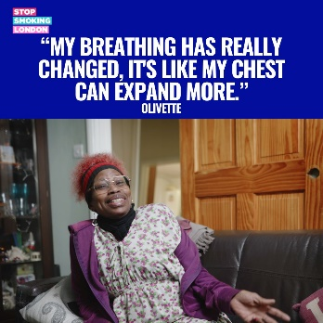  Use ‘Olivette’ graphic
Everyone’s journey to quitting smoking is different. That’s why @StopSmokingLondon have created a guide with hints and tips to help you deal with cravings and quit smoking for good 👇  https://stopsmokinglondon.com/stoptober/ | Everyone’s journey to quitting smoking is different. That’s why @StopSmokingLDN have created a guide with hints and tips to help you deal with cravings and quit smoking for good 👇  https://stopsmokinglondon.com/stoptober/  #Stoptober | 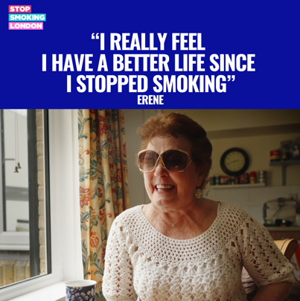Use ‘Erene’ graphic
You’re x3 more likely to quit for good when you combine expert support with quit smoking aids like nicotine replacement therapy or a vape or a vape.  Get the support you need to quit for good this #Stoptober with the @StopSmokingLondon guide to quitting smoking 👇  https://stopsmokinglondon.com/stoptober/ | You’re x3 more likely to quit for good when you combine expert support with quit smoking aids like nicotine replacement therapy or a vape.  Get the support you need to quit for good this #Stoptober with the @StopSmokingLDN guide to quitting smoking 👇  https://stopsmokinglondon.com/stoptober/ | 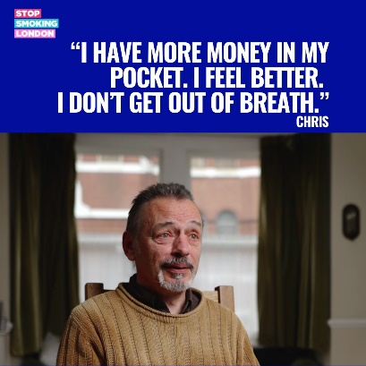  Use ‘Chris’ graphic
Join other Londoners quitting smoking for #Stoptober and get expert tips to deal with cravings and quit for good by downloading the @StopSmokingLondon guide to quitting smoking ⬇  https://stopsmokinglondon.com/stoptober/ | Join other Londoners quitting smoking for #Stoptober and get expert tips to deal with cravings and quit for good by downloading @StopSmokingLDN guide to quitting smoking ⬇  https://stopsmokinglondon.com/stoptober/ | 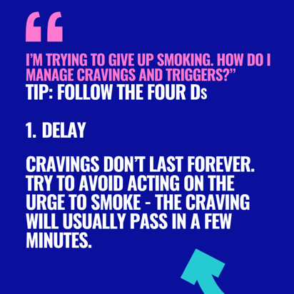  Use Tip 1
Remember – a craving will usually pass in a few minutes so don’t give in.  Keep on track with your quit attempt this #Stoptober and download the @StopSmokingLondon guide to quitting smoking with expert tips on how to cope with everyday smoking triggers  https://stopsmokinglondon.com/stoptober/ | Remember – a craving will usually pass in a few minutes so don’t give in.  Keep on track with your quit attempt this #Stoptober and download the @StopSmokingLDN guide to quitting smoking with expert tips on how to cope with everyday smoking triggers  https://stopsmokinglondon.com/stoptober/ | 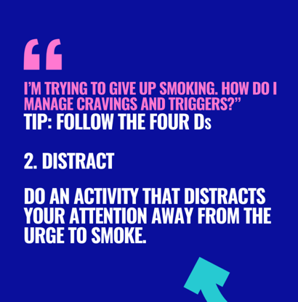  Use Tip 2 graphic
Everyone’s journey to quitting smoking is different but with support you can make a successful quit attempt this #Stoptober.  @StopSmokingLondon have created a guide with hints and tips to help you deal with cravings and quit smoking for good 👇  https://stopsmokinglondon.com/stoptober/ | Everyone’s journey to quitting smoking is different but with support you can make a successful quit attempt this #Stoptober.  @StopSmokingLDN have created a guide with hints and tips to help you deal with cravings and quit smoking for good 👇  https://stopsmokinglondon.com/stoptober | 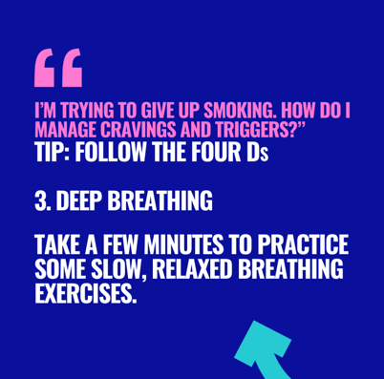  Use Tip 3 graphic
This #Stoptober, you can quit smoking for good with @StopSmokingLondon.  Take a look at their guide on how to quit smoking. You will find helpful information on how to find support, which stop smoking tools to use and practicable tips to help you deal with smoking triggers and cravings.  https://stopsmokinglondon.com/stoptober/ | Take a look @StopSmokingLDN guide on how to quit smoking. Inside it has info on finding local support, smoking tools to use and practicable tips to help with triggers and cravings.  https://stopsmokinglondon.com/stoptober/ | 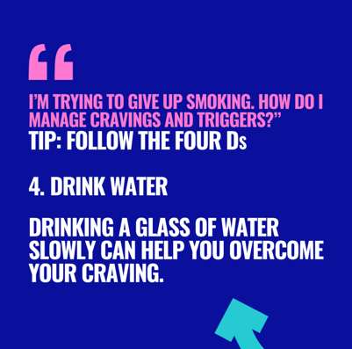  Use Tip 4 graphic

Let your residents know about the guide with an article on your external and internal sites
MAKE TODAY YOUR NO SMOKING DAY
If you want to quit smoking, STOPTOBER could be the motivation you need to start your quitting journey. It’s an annual campaign to help you find the support you need to stop smoking. Everyone’s journey is different and we are sharing stories we have from different people who have successfully given up.

And it’s never too late to quit. Erene, who lives in London, had been smoking for 60 years and lost several members of her family to smoking before she finally quit with help from her local stop smoking service. Now she plans to celebrate her 80th birthday without a cigarette. You can watch her video and read her full story here.

Olivette realised her health was being seriously impacted by her smoking and used this as her motivation to give up. Her advice to other smokers wanting to give up is that you can always try.

As his wedding day neared, Chris realised he wanted to give up. He appreciated quick wins as well as longer term wins like more money in your pocket, feeling better with no sore throats or getting out of breath. His message to anyone looking to stop smoking is “don’t stop trying to give up. You can and you will do it in the end. Believe yourself.”
Stop Smoking London is London’s resource for smokers who want help to quit. The website is full of hints and tips to deal with cravings, stories from people who have successfully quit. It has information and a search function to help you find your local stop smoking service as well as a text messaging service and helpline.

You’re three times more likely to quit for good if you combine professional support with a quit smoking aid like Nicotine Replacement Therapy so it’s important to get the right support for you.

Tracy Parr, Programme Director for Stop Smoking London says: “Free help is available for anyone in London who wants to quit and Stoptober is the ideal time as lots of people will be making a quit attempt. We know that everyone’s journey is different and that quitting smoking isn’t always easy so we’re here to help you find the support you need to quit for good.”

Visit www.stopsmokinglondon.com/stoptober

