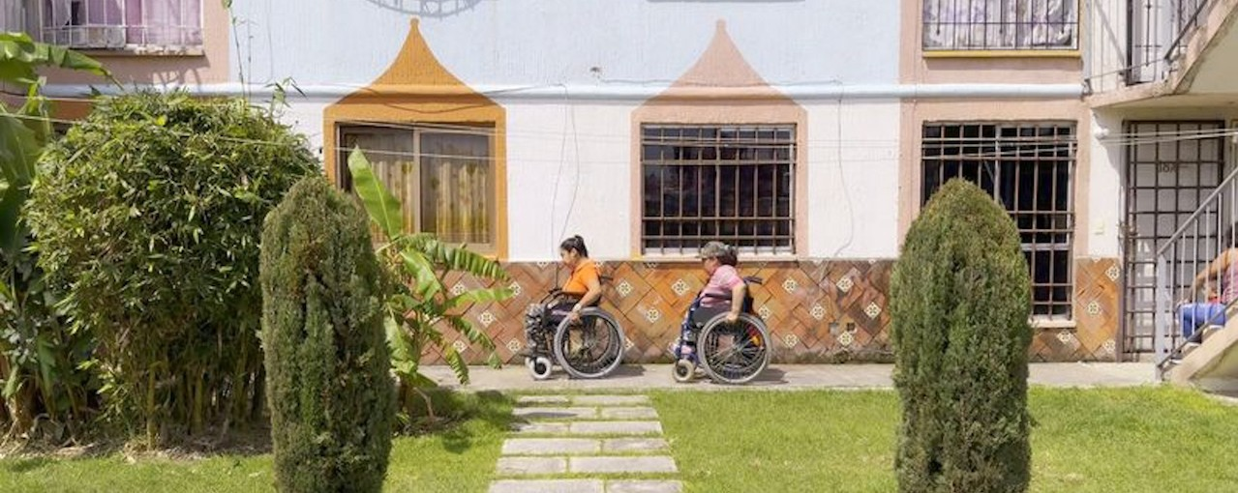


BFI FAN: Accessible Cinema Bulletin

Spring 2026

Welcome to the Spring 2026 edition of the BFI FAN: Accessible Cinema Bulletin.
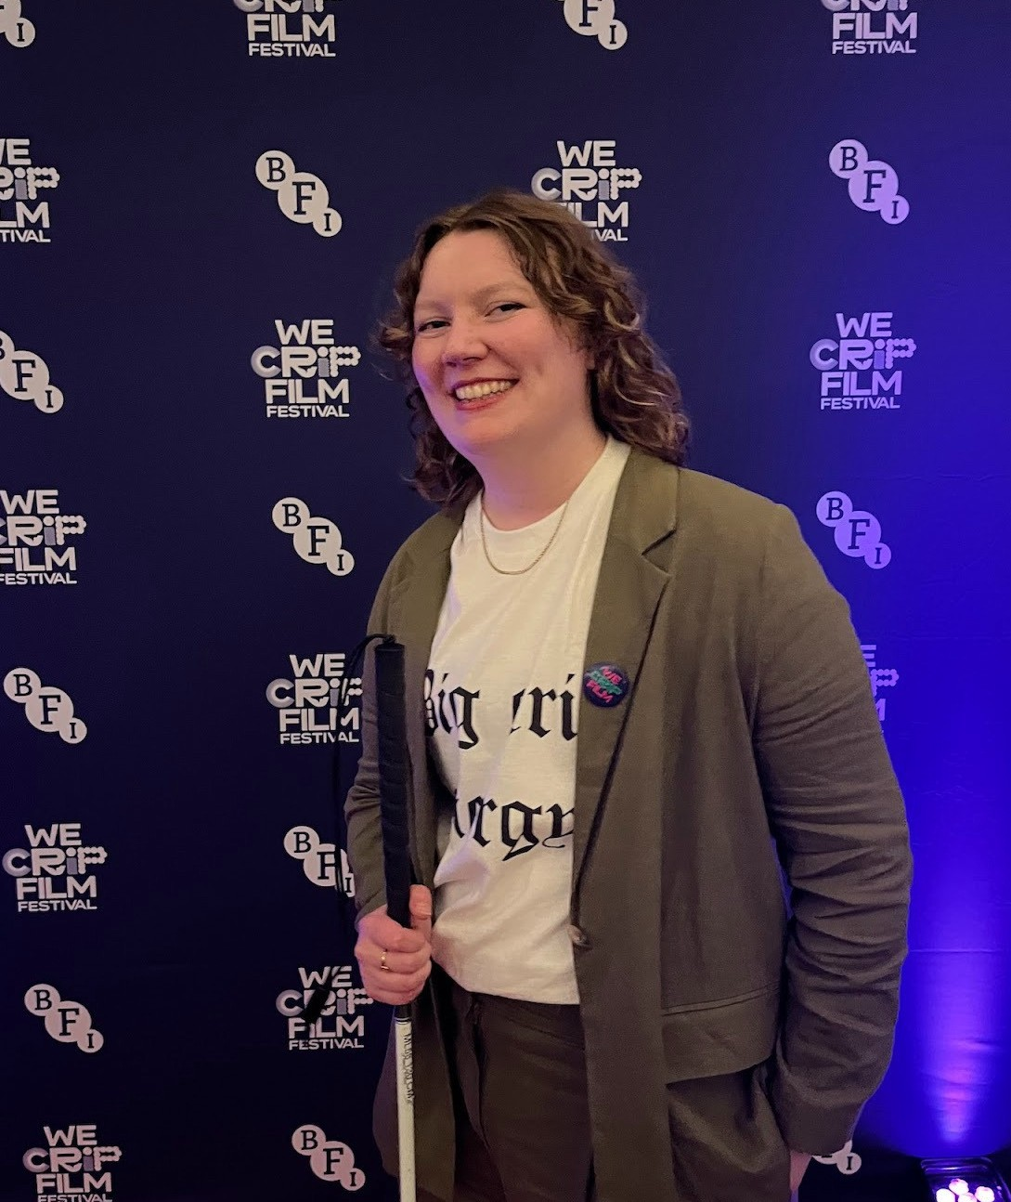
Charlie Little (Access Consultant, Matchbox Cinesub) is the BFI Film Audience Network (FAN) Champion for Equality, Diversity, and Inclusion. They support UK-wide Film Hub members with creating accessible and inclusive film events for Deaf and Disabled audiences.
This edition includes the latest news, resources, programming opportunities and events related to film exhibition access and inclusion.
Browse previous editions on the BFI FAN website. Charlie Little

Get in touch
If you know of any recent resources or upcoming events worth including in future editions, or if you have a question, please get in touch via:
info@ filmhubscotland.com.

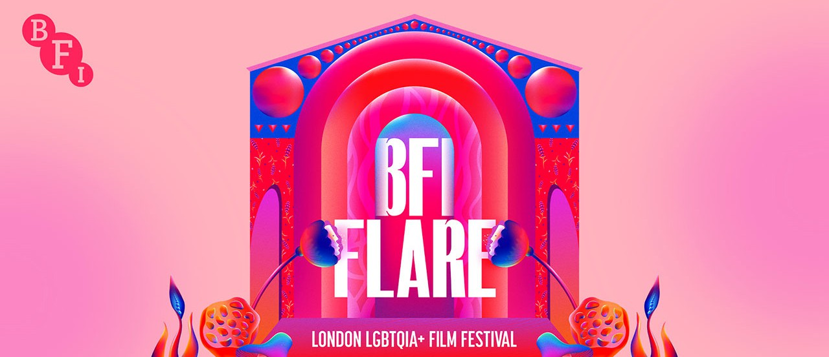
Events
BFI Flare: London LGBTQIA+ Film Festival 18 - 29 March | London
BFI Flare - the film festival celebrating queer cinema in springtime - is back for its 40th edition at BFI Southbank.
There is a range of access provisions at this year’s festival, including descriptive subtitles, audio description, relaxed screenings, live captioning, and BSL interpretation.

Key links:
- Festival accessibility information
- Accessible screenings at the festival
There are also some disability-focused films within this year’s programme:
- The Broken R - This Spanish-language portrait documentary follows Ricardo Ruales Eguiguren as he reflects upon his rare genetic condition and his sexual identity. Learn more.
- Rag Dolls - Available to watch for free on BFI Player until 29 March, Rag Dolls follows a married couple, Rosalinda (born with spina bifida) and Diana (who has cerebral palsy), as they navigate life in Puebla, Mexico, where their disabilities intersect with poverty and discrimination. Read more about the film on the British Council’s website.

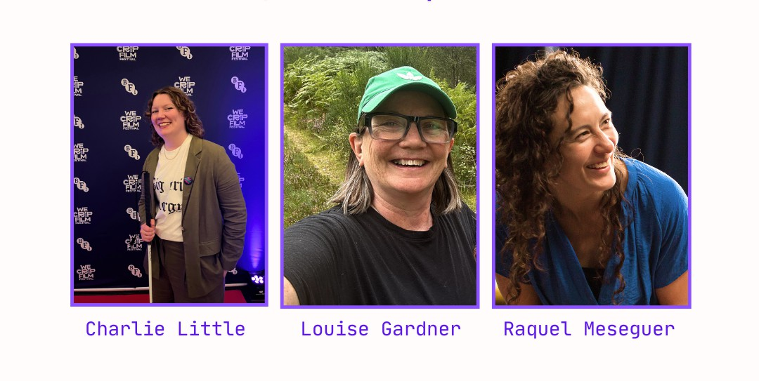

BFI FAN Webinar: Accessible Cinema for Audiences with Chronic Illness
26 March | Online
The next session in the BFI FAN EDI In Focus webinar series is a case study on Watershed’s provisions for chronically ill and immunocompromised audiences.
Charlie will be joined by Watershed’s Louise Gardner and Raquel Meseguer to discuss their Horizontal Cinema programme and Masked and Socially Distanced Screenings. This webinar is free for Film Hub members, and live captions will be available. Sign up for the webinar.

Scarborough Film Festival 26 - 29 March | Scarborough
Scarborough Film Festival (SFF) is back for its third edition, taking place across multiple venues. Based in the North Yorkshire seaside town of Scarborough, this festival spotlights alternative films whilst championing local filmmakers.
SFF 2026 will feature a relaxed screening of The Stimming Pool, an experimental film exploring the the neurodiverse experience. They will also provide a BSL-interpreted introduction for Pauline Black: A Two Tone Story, which will be shown with on-screen descriptive subtitles.

Donald Rodney : Three Songs On Pain, Time, and Light 28 March | Birmingham
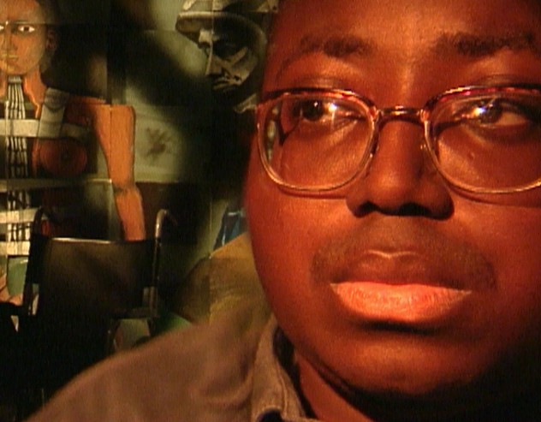
To mark Midlands Art Centre’s three year Expanding The Frame initiative to increase accessibility in the MAC Cinema programme, they will be premiering brand new audio description and creative captions for the acclaimed Donald Rodney short, Three Songs On Pain, Time and Light. Get tickets.

Oska Bright Film Festival
28 March - 2 April | Brighton
The 2026 edition of Oska Bright Film Festival is here! Oska Bright is the world’s leading festival for films made by or featuring people with learning disabilities or autism. The festival features a range of genres, from documentary to animation. This year, they’re introducing brand-new programming strands focused on poetry, nature, and horror. Explore the programme.

Deaffest 2026
8 - 10 May | Wolverhampton
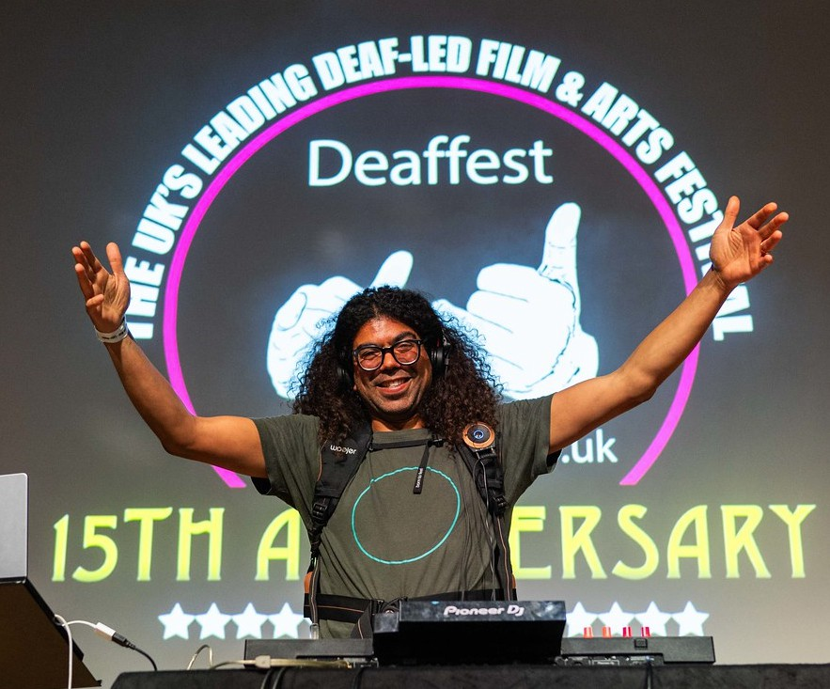
The UK’s leading Deaf-led film festival, Deaffest, returns for its 16th edition. This year’s theme - “sign in style” - is a celebration of costume and fashion design.
Festival screenings have sign language dialogue and subtitles, and showcase Deaf filmmaking
talent. Visit Deaffest’s website.

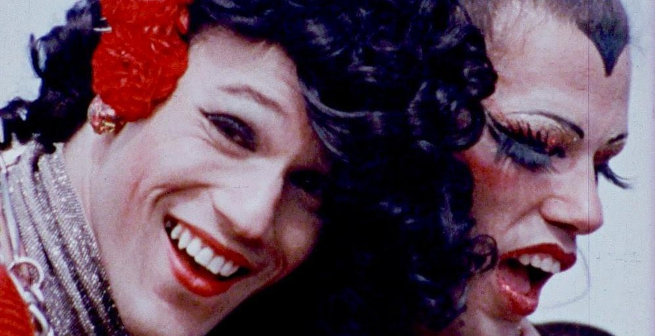
Resources

Inclusive Cinema
Resources, case studies and guides
Inclusive Cinema was a BFI FAN UK-wide project to widen knowledge-sharing on topics related to diversity and inclusion, including intersectionality and disabled audiences.
This website has useful case studies and resources to help you attract and maintain diverse audiences. It was recently updated with LGBTQ+ resources for LGBTQ+ History Month in February.
Find all resources and case studies on Inclusive Cinema’s website.

Accessibility Across the Board
Online course | Independent Cinema Office
Accessibility Across the Board offers practical steps to help your organisation develop a more accessible, inclusive culture for disabled audiences and staff.
Through recorded presentations and case studies, the programme will offer you practical guidance. Plus, you will get a sample Disability Action Plan to adapt. Learn more about the course.

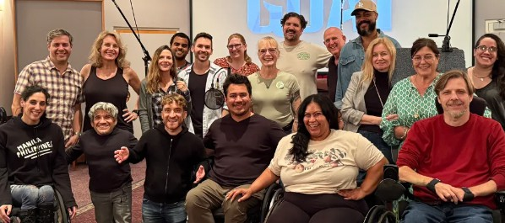
News & Articles

Variety : “Sony Pictures Animation’s ‘GOAT’ Makes History as First Major Studio Film Looped by an All-Disability Group”
The studio’s recent animated film, GOAT, features over two dozen actors with disabilities who lent their voices to the film’s crucial crowd noise. This made history as the first major studio film to be looped by an all-disability group, which was formed through the Easterseales Disability Film Challenge.
Read Variety ’s article.

Screen Daily : Accessibility mandate for video-on-demand services under new Ofcom regulation
The implementation of the Media Act 2024 will bring the UK’s largest video-on-demand (VoD) services under regulation by Ofcom. The new regulations will ensure that streaming services in the UK face the same accessibility mandate as UK broadcasters.
The new VoD accessibility code will require streamers such as Netflix, Prime Video, and Disney+ to ensure that at least 80% of their total catalogue is subtitled, 10% is audio-described, and 5% is signed.
Whilst this mandate brings a new level of accountability and enforcement for streaming services and their standard of access provisions, this news has

been met with mixed opinions.
Many people have noted that some of these providers already have a higher provision than what is mandated, for example, Netflix’s provision of subtitled content. The mandates for sign language and audio description are also considerably low compared to the one required for subtitles.
Read the Screen Daily Article | Read more about Ofcom’s regulations

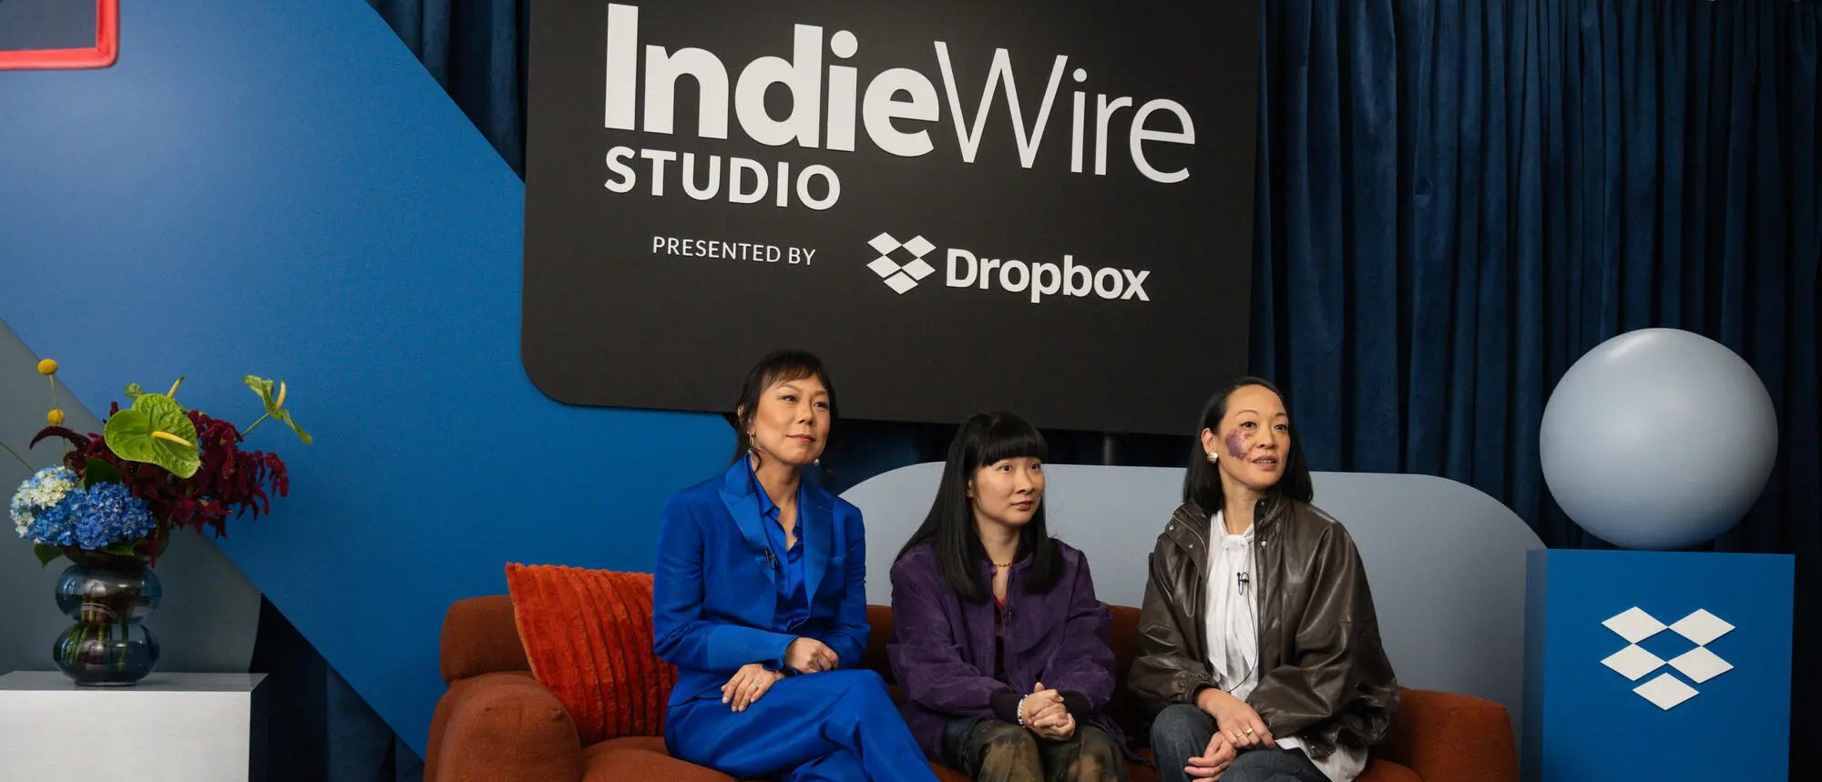
IndieWire: “Sundance’s ‘Take Me Home’ Turned a Personal Story Into an Anti-Ableist Creative Undertaking”
Premiering at Sundance Film Festival, Take Me Home (2025, dir. Liz Sargent) follows Anna, a 38-year-old Korean adoptee with a cognitive disability, as she cares for her aging parents. When a Florida heat wave shatters their family and Anna’s routine, her future is uncertain until she creates a world where she can thrive.
This interview with the director and lead actor delves into the film’s anti-ableist aims and how accessibility - including cognitive accessibility - was embedded throughout the filmmaking process. Read the article.

Deadline: ‘Disabled Creatives Join Development Programme to Reclaim the Horror Genre’
A development programme has been launched in the UK to support disabled

creatives to break into the genre of horror, a genre historically known for problematic depictions of disabled people. Supported by 104 Films and the BFI Creative Challenge Fund, 10 projects will be in development over the coming months.
Read the Deadline article.

