FABRIC Fund
Guidelines: 2026-29

About Film Hub Scotland

The BFI Film Audience Network (FAN) reaches audiences across the UK to provide them with the opportunity to watch and enjoy a diverse range of films, regardless of their geography or circumstance.
Film Hub Scotland is one of eight Film Hubs that make up BFI FAN. Jointly funded by the BFI and Screen Scotland via the National Lottery, we support Scottish film exhibitors to reach a broad range of audiences with independent UK and international film, and to deliver against the priorities set out in BFI’s Screen Culture 2033 strategy .
To access support from Film Hub Scotland, you must first become a member. Membership is free and offers many benefits, including training, funding, programming support, and access to the latest industry news.

Support to complete your proposal
We recognise that people process information in different ways. If you’d like to access these guidelines in a different format, or would benefit from an initial chat with our team before you get started, please get in touch:
info@filmhubscotland.com.
If you require assistance when writing your proposal, you can request financial support through the BFI Access Support Scheme.

What is the Fabric Fund?
The Fabric Fund supports and encourages film exhibition in rural, remote, and/or island areas of Scotland. We recognise the positive impact of building local networks and devolving our oversight to support community cinemas across Scotland. Fabric aims to remove barriers for screen audiences, ensuring accessible and affordable cinema is available to everyone in Scotland.
When submitting proposals for Fabric projects, you should provide an overview of the area where the project will take place. We’d like to learn more about the demographics, specific needs, and existing screening activity.

Your proposal should show how you will grow the number and range of film exhibition opportunities for audiences in your area.
Organisations delivering Fabric projects should already have local knowledge, contacts with a range of relevant organisations, and significant experience of delivering film events within your geographical area.

Key information
Fund opens: 9 March 2026

Deadline: 30 March 2026 - if you cannot meet this deadline comfortably, please let us know.

Film Hub Scotland members can submit proposals between £5,000 and
£20,000 per year for 2026-29, up to a maximum of £60,000 across three years. You may apply for one, two, or three years of funding as suits your organisation.
Proposals are preferred from organisations who are able to undertake a three-year programme to develop audiences in their identified area, with ambitions to continue after 2029. However, we will also consider proposals for shorter projects in new areas where cinema audiences are under-served by existing provision.
We will accept joint proposals, as long as there is a clear delivery structure and a lead applicant.

We are happy to discuss your proposal at any stage. Please get in touch:
info@ filmhubscotland.com.

Levels of support
We anticipate only the strongest proposals to receive the maximum award of £20,000 per year for the entire three-year period. We expect most projects to be granted a reduced award and/or a reduced period of support.
If you are not certain about the level of support that you can expect, the following expectations are indications of how we anticipate to allocate funding:

- Projects with highly experienced organisers, a strong track record of delivery in 2023-26 and/or earlier, high annual admissions, and an exceptionally well-articulated plan of activity in 2026-29 are likely to be awarded between £17,000 and £20,000 for two or three years

- Projects with experienced organisers, realistic annual admissions, a solid record of delivery in 2023-26 and/or earlier, and a well-justified area of delivery, are likely to be awarded between £13,000 and £17,000 for one-and-a-half or two years

- New projects, projects delivered by new organisers, previous recipients that achieved significantly fewer admissions than their target in 2023-26, and/or strong proposals involving significant unconfirmed partnership(s) or multiple yet-to-be-opened venues, are likely to be awarded up to £15,000 for up to 1.5 years

The above levels of support are indicative only and based on our current experience with Fabric. They may change significantly based on the strength and number of proposals we receive.

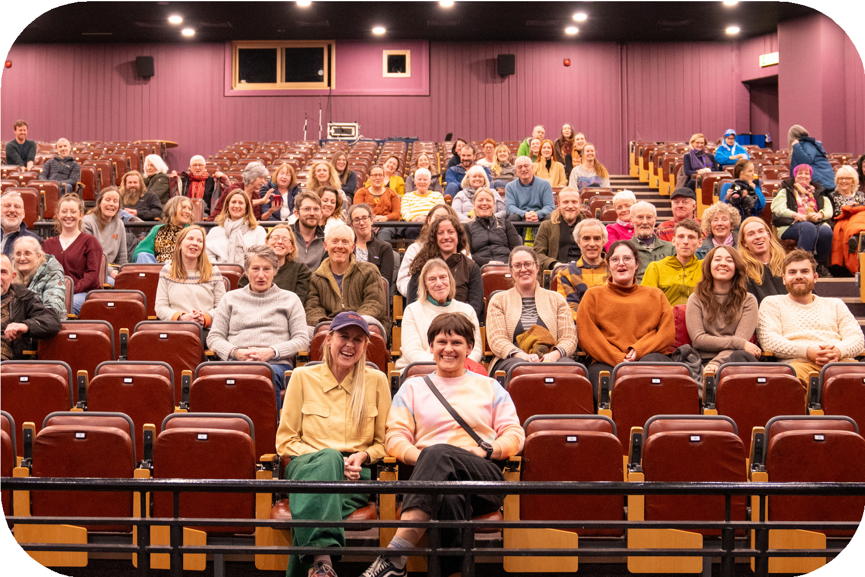

Strategic Priorities

Film Hub Scotland is focused on increasing access to screen culture and growing audiences that are representative of the UK population.
Fabric proposals should refer to the our strategic priorities as outline by BFI’s Screen Culture 2033 strategy. In particular:

Funding helps tackle social, economic and geographic barriers for screen audiences in new and effective ways
Our ambition is to give everyone, everywhere in the UK the opportunity to engage with a diverse range of cinema - tackling physical access as well as psychological, economic or cultural factors. This fund aims to maximise the number and range of audiences engaging with independent film across Scotland, especially those from working class communities, specific underrepresented audiences and those who are suffering economic hardship. We are interested in supporting projects (including pilots) that try out new ways of reaching specific target audiences.

Regional Network organisations are in a unique position to widen the geographical impact of FHS funding, develop relationships with community groups and initiate new effective ways of increasing engagement with film.
The other priority areas are:

Children and young people are empowered to develop their own relationships with a wider range of screen culture
The BFI recognises that early cinema visits are important for the health of the exhibition sector, so our funds can support you to engage with children, families and young people (25 and under). Your activity may be aimed at welcoming children, young people or family groups to your events, or you may work with a Young Programmers’ group to curate your programme. If working with children and young people, you will need to demonstrate that you have safeguarding policies in place.

People across the UK can access a wider choice of film and the moving image, including stories that reflect their lives
One of our key aims is to support public access to a wide range of film and the moving image including classic and international cinema, documentaries, TV and screen heritage, games and work that creates risks. New for this area, we are interested in exploring the opportunities for audience engagement within immersive and interactive technologies. We also wish to boost the number of stories on screen that reflect the lived experiences of our diverse populations.

More people can engage with heritage collections that better reflect the diversity of the UK
We want to see proposals that allow your audience to experience screen heritage in creative, relevant and engaging ways that reflect the diversity of Scotland and the UK. We can support activities that showcase various types of screen heritage material – from restored silent cinema to archived family footage documenting the past. If your proposal includes archival material, please ensure you have contacted the relevant archival collection before seeking support from us.

Cross-cutting Principles
Also underpinning our work are the following cross-cutting principles that all supported activity will need to address:

Equity, Diversity and Inclusion (EDI)
In line with the BFI Diversity Standards, we encourage activity aimed at, and/or co-produced with, under-represented groups. We want to see how your project considers access and inclusion from the beginning. We want to know how it will contribute to diversifying audiences for the widest range of cinema, and broaden the range of stories represented on screen.

We are particularly committed to ensuring disproportionately affected audiences, such as under-served ethnic groups, disabled, D/deaf, and neurodivergent people, can experience independent film and be welcomed into cinema spaces. We strongly encourage activity aimed at and/or co-produced with these groups. All Fabric proposals will be asked to demonstrate how their activity promotes inclusivity among audiences and on screen. Where applicable, we also value projects that tackle underrepresentation in the exhibition workforce.


EDI Resources
Film Hub Scotland - Access & Inclusion resources
BFI FAN - data, case studies and how-to-
guides to support UK film exhibitors

Environmental Sustainability
We are committed to minimising the negative environmental impact of the work we support and ask all member recipients to contribute to this aim. In your proposal, please summarise steps you are taking both to minimise the environmental impact of your activity and to improve audience awareness of the climate and biodiversity crises.

We ask you to consider the environmental sustainability of your project and take steps to reduce the impact where possible and feasible.


Sustainability Resources
BFI resources for sustainable film exhibition Culture for Climate Scotland - sign the Green Arts Charter
Julie’s Bicycle - lots of resources, including the Creative Climate Tool

Continuation of funding
The Fabric programme is supported by the BFI National Lottery and Screen Scotland.
Funding in 2027/28 and 2028/29 is subject to yearly confirmation by both funders. Even in the case of two- or three-year awards, we cannot fully guarantee the availability of funding for the entire period.
In the unlikely case that funding for Fabric is reduced or cut altogether, we will give you the earliest possible notice and work towards alternative solutions.

Eligible Expenses
Each organisation will have its individual need. However, broadly speaking, the Fabric Fund can support the following project costs:
- Coordination staff for delivery of project

- Administration costs to support delivery of activity

- Travel and accommodation costs for delivery of activity

- Film licensing and print transferring/transportation costs

- Venue hire and activity-specific equipment costs

- Marketing, advertising and PR campaigns

- Event costs for enhanced screenings - e.g. speaker, talent or artist fees

- Volunteer and front-of-house expenses

- Reporting and evaluation expenses

- Accessibility costs - e.g. commissioning Descriptive Subtitling, providing live-captioning, BSL interpretation

- Outreach and community inclusion costs - e.g. providing transport for isolated audiences

- Audience development expenses - e.g. young programmers’ workshops

- Curation and licensing for screen heritage and archival materials This list is not exhaustive, and other items may be considered.

All proposed spend should contribute to the activity for which you are seeking support.

Ineligible Expenses
There are expenses that are not suitable for support from the Fabric Fund:

- Filmmaking costs (including workshops), support for filmmakers to develop or distribute their own work, or for programmes that exclusively engage filmmaker audiences

- Capital costs

- Screenings where audience numbers cannot be reported

- Activity that should be covered by statutory education, including events taking place on school grounds/in school hours

- Closed events which are not open to the public, including student film events, industry showcases, or unticketed events where numbers cannot be reported

- Exclusively submissions-based programmes

- Events not primarily focused on film exhibition or screen culture

- Activity covered by existing Film Hub Scotland funding arrangements –
i.e. projects already receiving other FHS funding

- Activity taking place in a venue not open to the public – e.g. members-
only venues

- Charity fundraising screenings

Again, this list is not exhaustive, and we will use our discretion to determine the eligibility of requested costs.

Got a question?
Email us: info@ filmhubscotland.com
If you would like to discuss submitting a proposal in a different way, please get in touch with our team who will be happy to discuss this.

