BFI FAN: Accessible Cinema Bulletin | Winter 2025

Welcome to the Winter 2025 edition of the BFI FAN: Accessible Cinema Bulletin!

Charlie Little (Access Consultant, Matchbox Cinesub) is the BFI Film Audience Network’s Equality, Diversity, and Inclusion Champion, supporting the UK-wide FAN membership on access and inclusion for Deaf and Disabled audiences. This regular bulletin focuses on sharing recent news, resources, and upcoming films and events related to disability and access within the film industry.
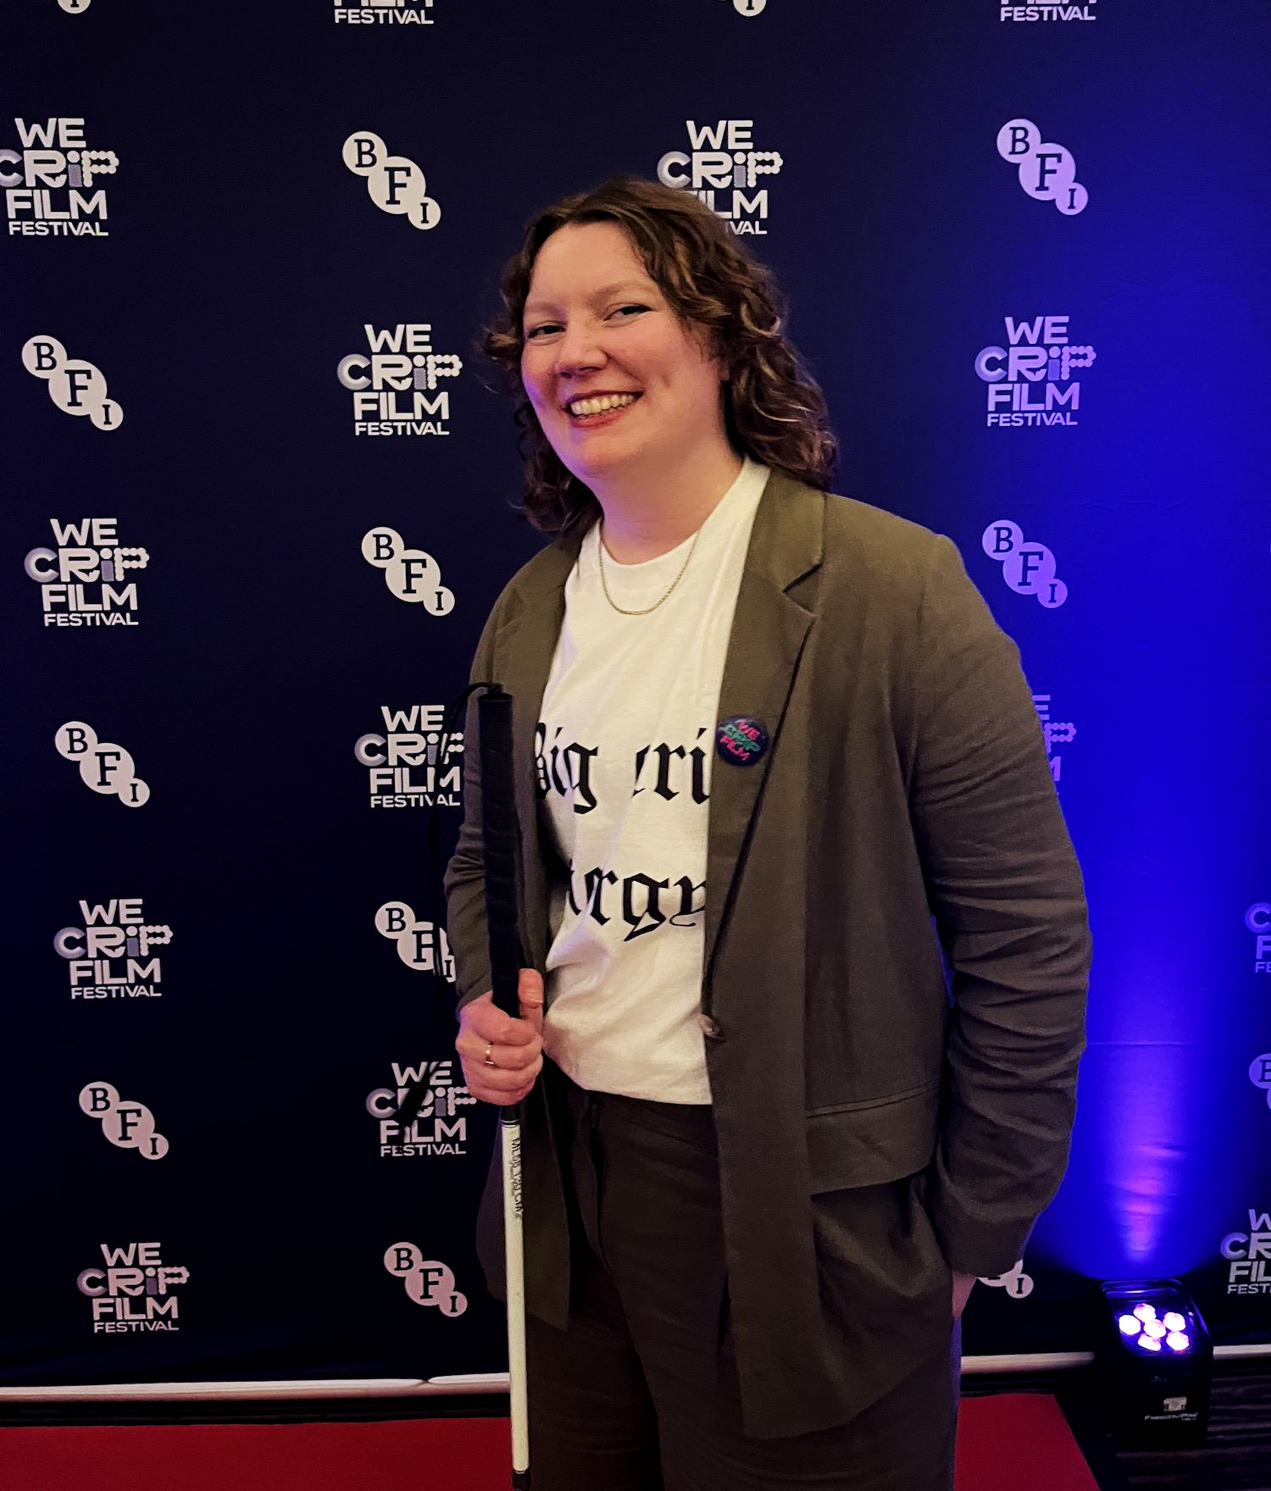
Charlie Little, BFI FAN's EDI Champion
If you know of any recent resources or upcoming events worth including in future editions, or if you have a question, please email: info@filmhubscotland.com.

This edition includes:
- Events
- News & Articles
- Resources

Disability History Month is from 20 November - 20 December. This year’s theme is Disability, Life, and Death.

→ Learn more via UKDHM’s website

Events

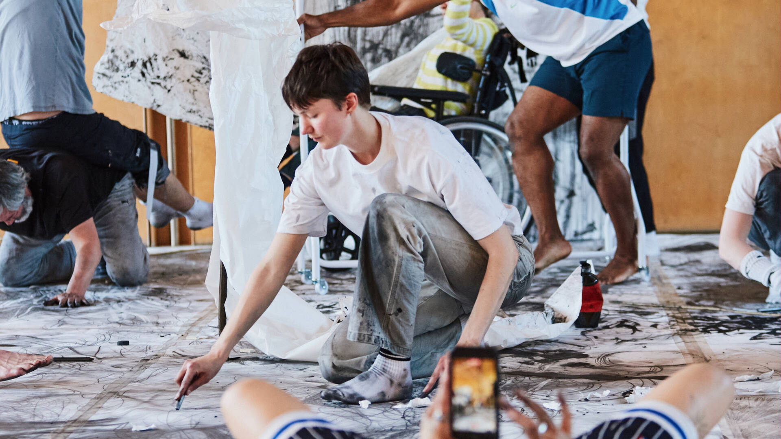
Friday Late: Radical Kinship reimagines relating to the world through disabled creativity

Friday Late: Radical Kinship | Crip Cinema Archive
28 November | V&A South Kensington, London

Crip Cinema Archive, an online archive documenting disability on screen, will be screening three films examining how disability shapes our sense of time, agency, and presence. The films will be played on a loop at the V&A South Kensington.

“Friday Late is a free event reimagining how we relate to the world through disabled creativity. No tickets, just turn up on the night for some crip magic.”

→ Tickets and access information

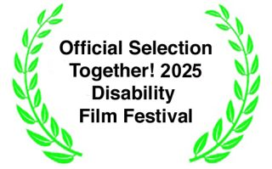
Together! Disability Film Festival
6-7 December | Online

Together!’s annual Disability film festival will be taking place online over YouTube, with industry events taking place over Zoom.

Every day, six programmes will be made available online, exploring animation, dance, documentary, drama, artist films, and the International Day of Disabled People.

→ Tickets and access information

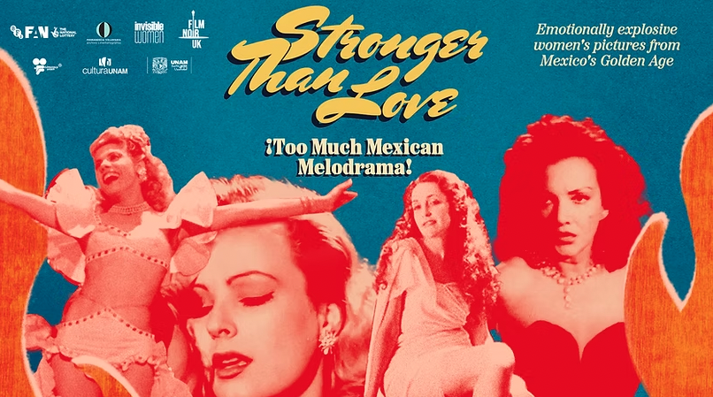

Invisible Women | Stronger Than Love:¡Too Much Mexican Melodrama!
December | Edinburgh, Cardiff, London

Invisible Women have curated a touring season of restored Mexican melodrama classics from the 1930s-50s. Invisible Women commissioned brand new Descriptive Subtitles (DS) from Matchbox Cine for one of these titles, and there are several scheduled accessible screenings taking place across different venues. Find more information about the film below!

Más Fuerte que el Amor (Stronger Than Love, 1955)

“This intoxicating melodrama stars Miroslava Stern as Barbara, a wealthy industrialist’s daughter whose desire for Carlos (Jorge Mistral), a former worker turned business partner, defies social codes and patriarchal control. With torrential storms, moonlit beaches and sweeping Cuban backdrops, Stronger than Love ignites with passion, situating female lust and agency at the heart of its fiery drama.”

Find the scheduled DS screenings below:
→ Filmhouse, Edinburgh: 2 December
→ Chapter Arts Centre, Cardiff: 7 December
→ Rio Cinema, London: 17 December

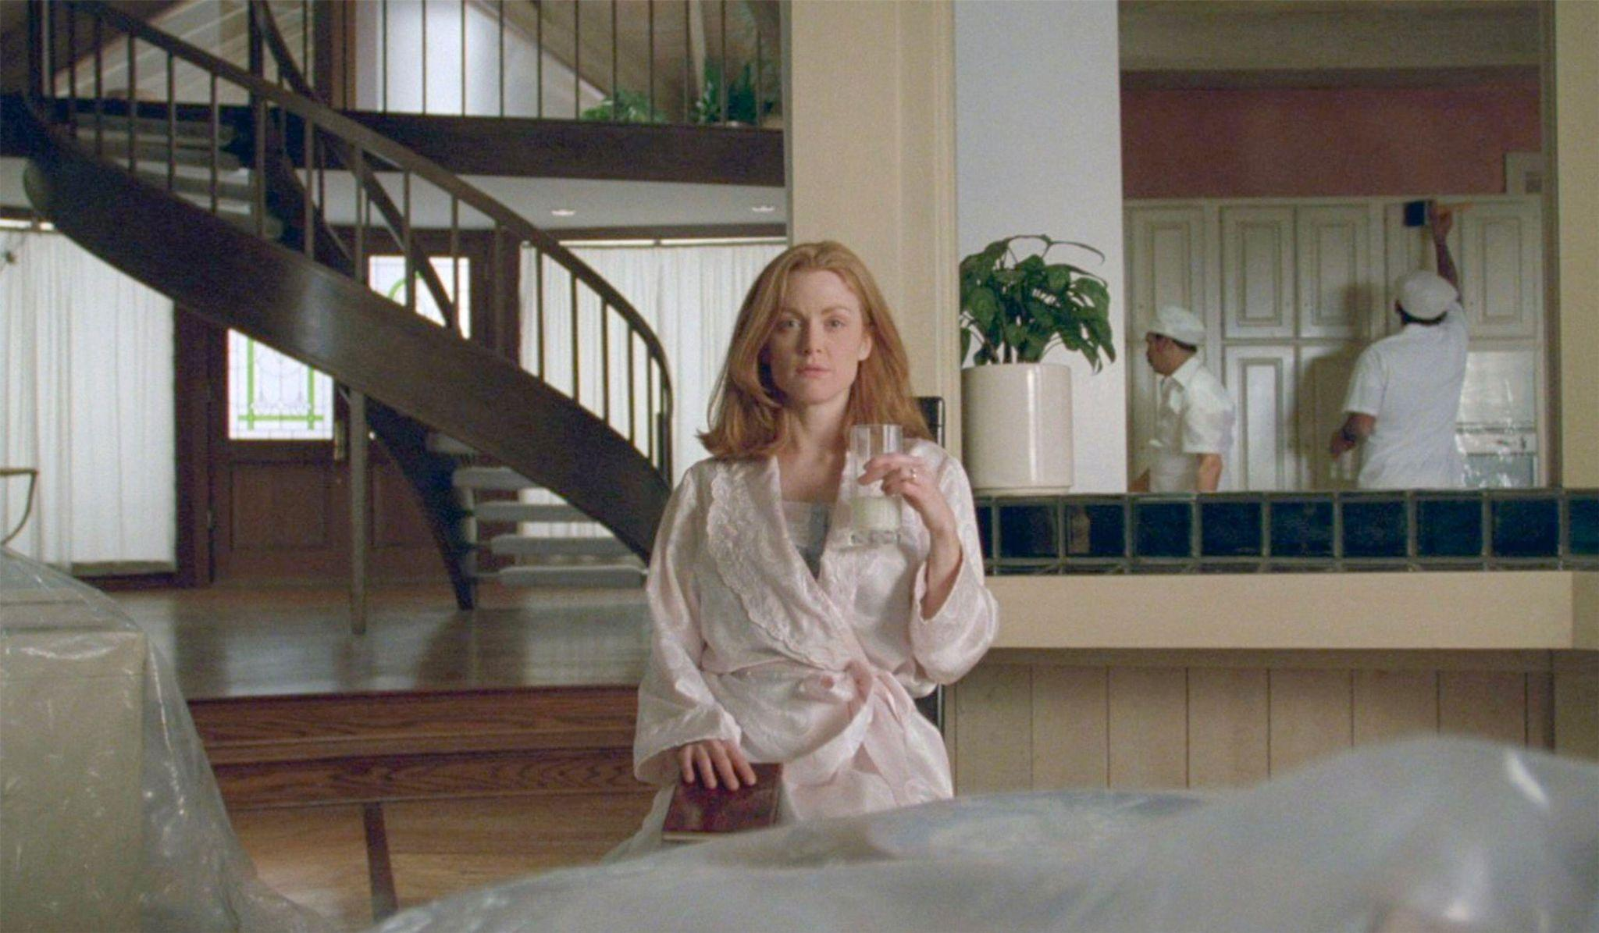
SAFE (1995, dir. Tod Haynes)
Crip Melodrama: She’s Hysterical
December | Birmingham, Bristol

In partnership with Independent Cinema Office, three disabled curators (Emily Simmons, Charlie Little, and Florence Grieve) have curated a mini-tour of Safe (1995) screenings and events that examine the representation of disabled women across melodrama. There are two more events taking place in December:

- Midlands Art Centre (MAC), Birmingham | 7 December - This film screening will be followed by a relaxed zine-making workshop with Florence Grieve.
- Watershed, Bristol | 14 December - This film screening will be followed by a discussion with Lindsey Dryden, hosted by Florence Grieve.

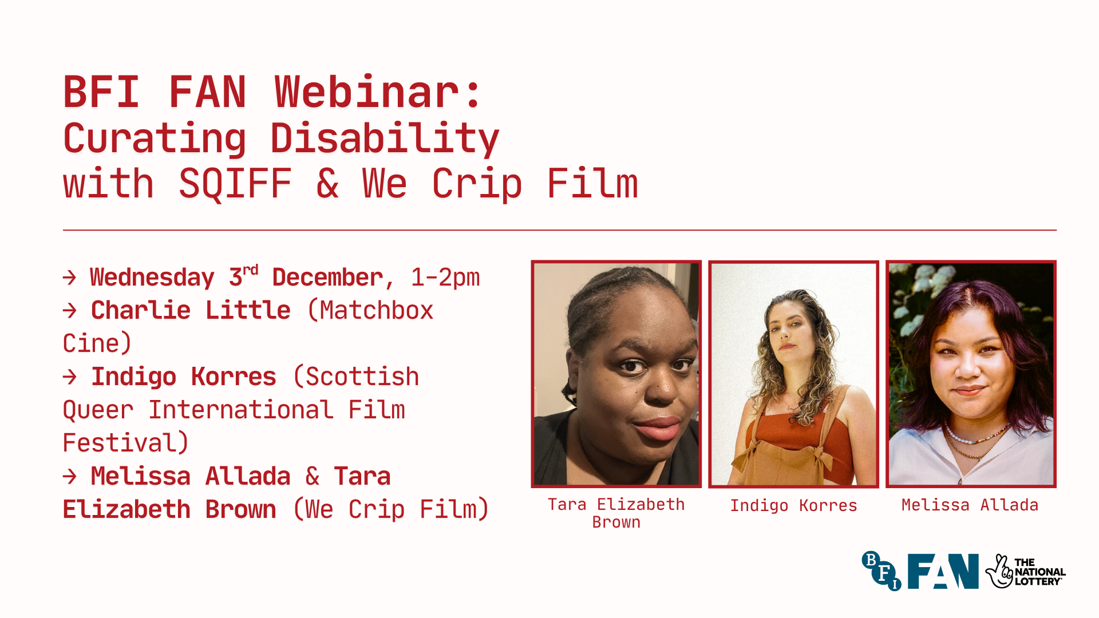

BFI FAN Webinar | Curating Disability with SQIFF and We Crip Film
3 December | Online

Marking International Disabled People’s Day on 3rd December, the next BFI FAN Equality, Diversity & Inclusion webinar will explore how disability-focused programming can be meaningfully embedded within film exhibition.

Charlie Little will welcome Indigo Korres (Director, Scottish Queer International Film Festival) and Melissa Allada & Tara Elizabeth Brown (BFI’s We Crip Film Festival) to present case studies and answer questions. The session will be live captioned and recorded

→ Sign up for the webinar

Gallivant | Relaxed Screening
14 December | The Garden Cinema, London
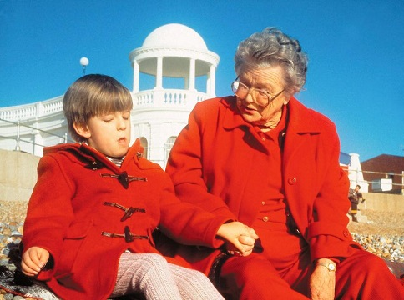
GALLIVANT (1996, dir. Andrew Kotting)
Kinoema will present a relaxed screening of Andrew Kotting’s Gallivant (1996), in collaboration with The Garden Cinema, followed by a Q&A with the director. There will be a short film before the screening, Diseased and Disorderly (2021, dir. Andrew Kötting).

“Gallivant, the director’s first feature work, is an archive of livelihood; he brings together his grandmother and his daughter, who has Joubert syndrome and had been told she would not live long, to get to know each other whilst they interview locals during their journey.”

→ Tickets and access information

News and Articles
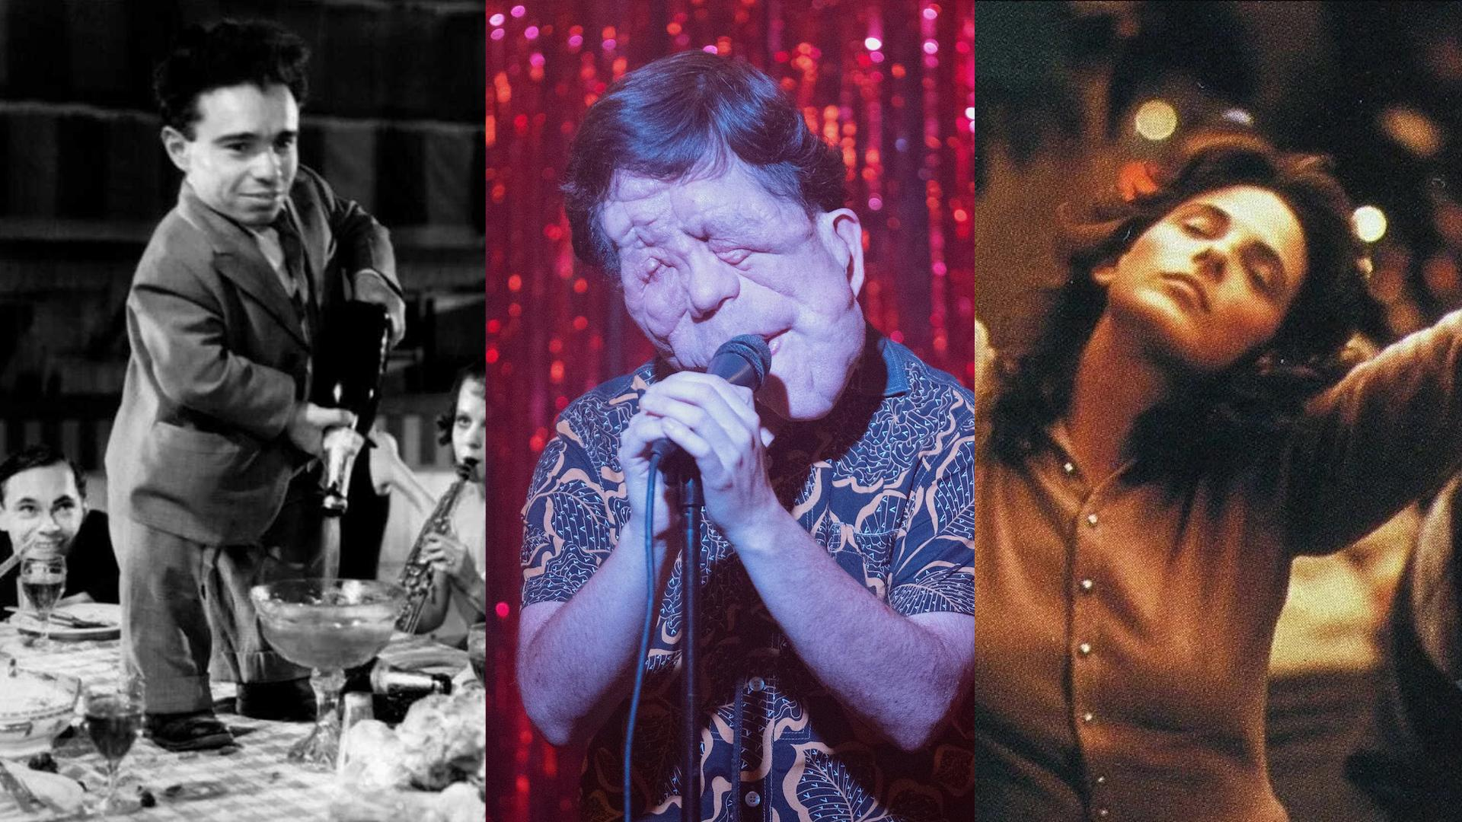
Stills from Freaks (1932), A Different Man (2024) and Children of a Lesser God (1986)

Letterboxd | Starter Pack for Disability Visibility

“With her book Popcorn Disabilities soon to hit shelves, author Kristen Lopez oﬀers a starter pack of twenty ﬁlms about disability—from the good (The Best Years of Our Lives) to the not-so-good (Rain Man)—unpacking common tropes and contextualising their depictions.”

Find more information about Popcorn Disabilities, which will be available to purchase from Bloomsbury.

→ Read the article - Disability Visibility: a starter pack on twenty depictions of disability on film

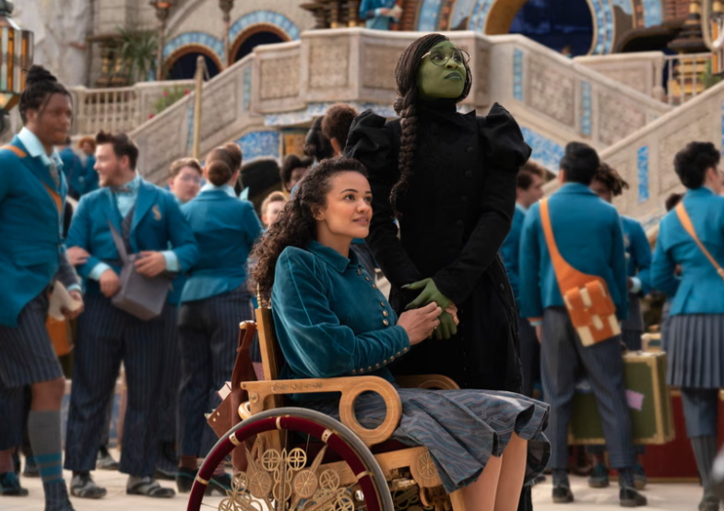
WICKED: FOR GOOD (2025, dir. Jon M. Chu)

The Guardian | Wicked: For Good and Disability Representation

In this article and interview with Marissa Bode, who was the first wheelchair-user to play the character of Nessarose, the Guardian explores authentic disability casting and representation.

“Bode is calling on casting directors to follow Wicked director Jon M Chu’s lead to use disabled actors for disabled roles, and also to cast disabled actors in other roles where the character’s physical ability is not specified.”

→ Read the article - ‘It’s important that we tell our own stories’: how the Wicked movies are helping disability representation on screen

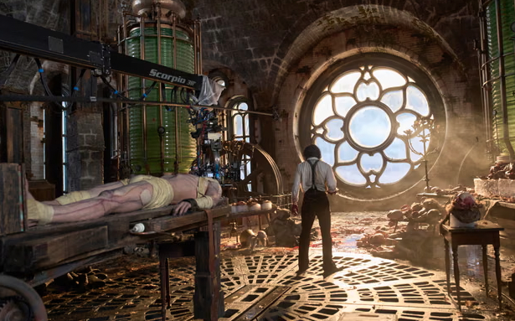
FRANKENSTEIN (2025, dir. Guillermo del Toro)

The Guardian | Frankenstein and Disability Horror

In this article by Kathryn Bromwich, a horror fan with a disability, she discusses the horror genre’s historical issue with using disability to reference depravity or villainy. The article looks at Guillermo del Toro’s recent adaptation of Frankenstein and its approach towards casting and representation.

→ Read the article - Horror movies have an ableism problem. Isn’t it time we found new ‘monsters’?

Resources

BFI FAN Webinar | Relaxed Screenings
Online Recording | UK

In the latest edition of the BFI FAN: EDI In Focus webinar series, Charlie Little was joined by Georgia Kumari Bradburn (co-director, The Stimming Pool, and co-curator, Stims) to discuss relaxed screenings and how exhibitors can mindfully engage neurodiverse audiences.

→ Watch the recording on YouTube (optional captions available)

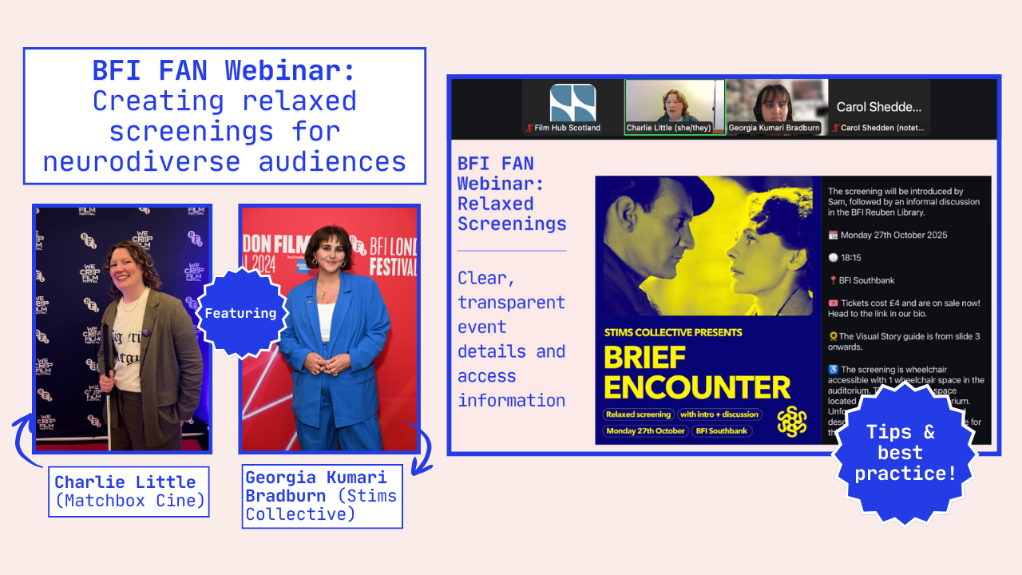

BFI FAN | Reducing Socio-Economic Barriers for Cinema Audiences

Written by Linnea Pettersson, BFI FAN Socio-Economic Champion, this Guide is updated on a regular basis and was created to support exhibitors with identifying and addressing socio-economic barriers for audiences. The Guide includes information on ticketing, funding opportunities, data, and blogs related to this issue.

→ Read BFI FAN: Reducing Socio-Economic Barriers for Cinema Audiences

