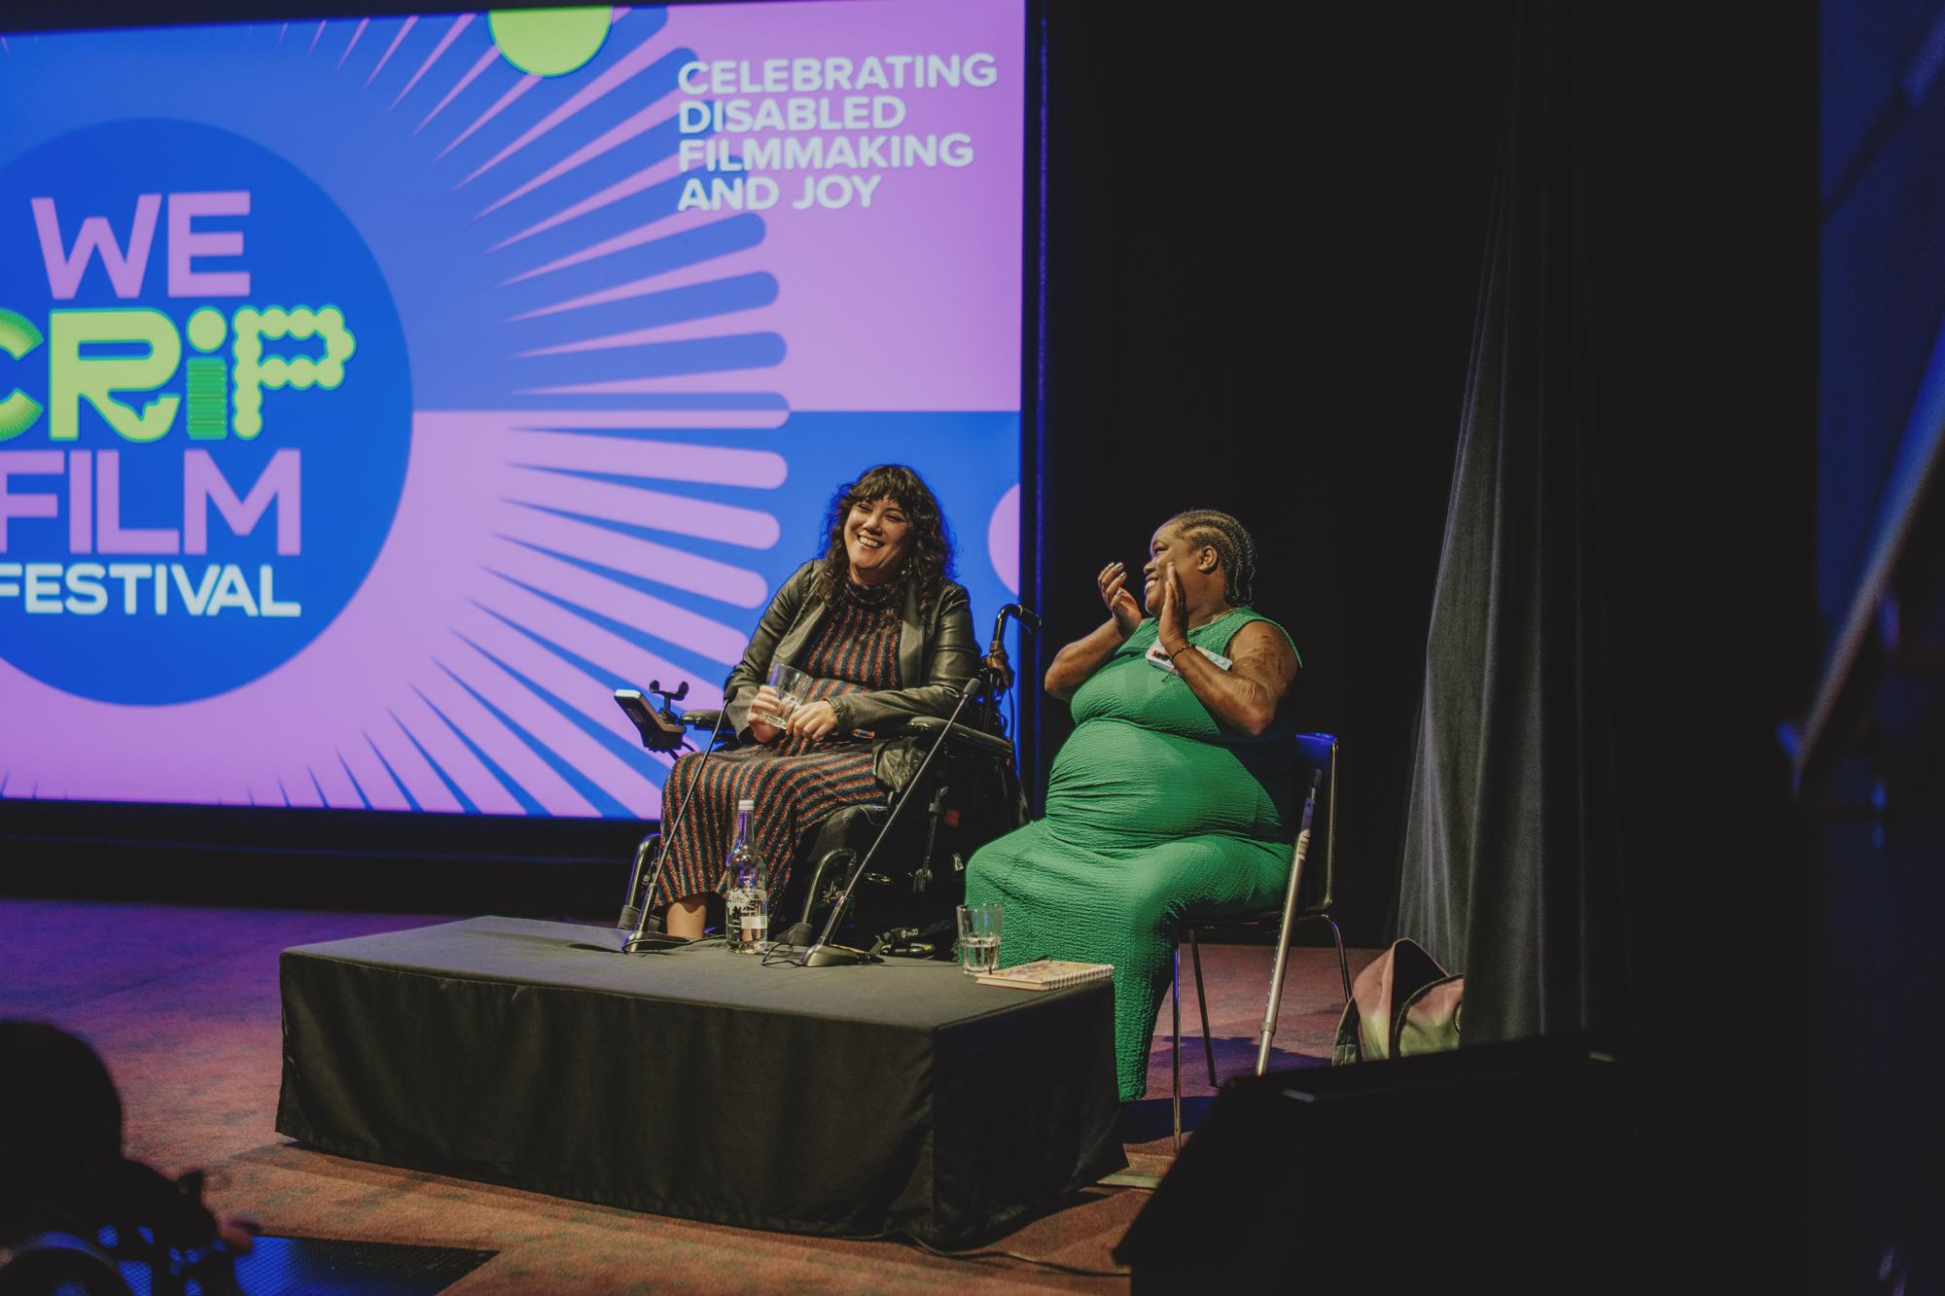**BFI FAN: Accessible Cinema Bulletin | September 2025**

An Audience with Kyla Harris: Cripping the Screen Industries at BFI We Crip Film Festival. Photograph by Jessica Sansom.

Welcome to the Autumn 2025 edition of the **BFI FAN: Accessible Cinema Bulletin**!

Charlie Little (Access Consultant, [Matchbox Cinesub](https://matchboxcine.com/)) is BFI FAN’s Equality, Diversity, and Inclusion Champion for Film Hub Scotland, supporting the FAN membership on access and inclusion for Deaf and Disabled audiences. This regular bulletin focuses on sharing recent news, resources, and upcoming films and events related to disability and access within the film industry.

If you spot any articles or resources worth including in future editions, or you have a question, please email [info@filmhubscotland.com](mailto:info@filmhubscotland.com).

This edition includes:

* Events
* News & Articles

## **Events**

[**DEAF Film Screenings**](https://www.curzon.com/films/deaf/HO00006356/)

**September, UK**

Directed by Eva Libertad, DEAF follows a young deaf woman and her hearing partner, who are expecting a baby. Unable to know whether their child will be hearing or deaf until birth, it’s a beautiful, nuanced depiction of their journey. The clever use of sound and silence immerses us in Ángela's experience and explores the struggles she faces, given the inadequacies of the world for deaf people.

This film will be screened with **descriptive subtitles as standard** in all cinemas. Find the trailer and details about screenings on [Curzon’s website](https://www.curzon.com/films/deaf/HO00006356/).

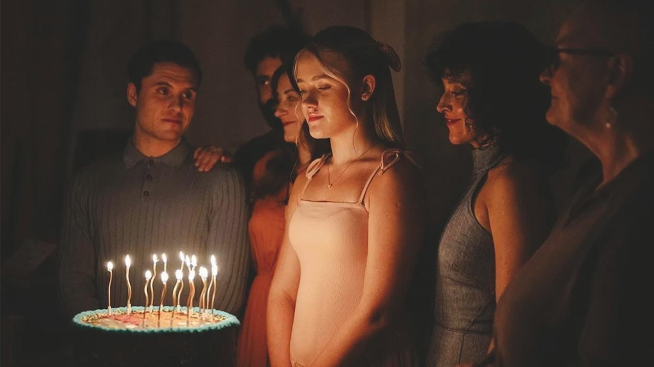

Retreat (2025) dir. Ted Evans

[**Disability Visibility | BFI London Film Festival**](https://whatson.bfi.org.uk/lff/Online/default.asp?BOparam::WScontent::loadArticle::permalink=access)

**8 - 19 October, London**

The 69th BFI London Film Festival returns to London and venues around the UK. This year’s lineup includes a few different disability titles within the programme:

**LIFE AFTER**

‘Reid Davenport’s thought-provoking and personal project explores the complex debates and hidden motives surrounding assisted dying.’

[Find screenings of LIFE AFTER.](https://whatson.bfi.org.uk/lff/Online/default.asp?BOparam::WScontent::loadArticle::permalink=life-after-lff25&BOparam::WScontent::loadArticle::context_id=)

**RETREAT**

‘In Ted Evans’ gripping thriller, the arrival of an outsider to an isolated Deaf community forces one of its members to question this seemingly idyllic utopia.’

[Find screenings of RETREAT](https://whatson.bfi.org.uk/lff/Online/default.asp?BOparam::WScontent::loadArticle::permalink=retreat-lff25).

**D IS FOR DISTANCE**

‘This deeply personal rumination on memory and the moving image offers a frank and uncompromising insight into medical bureaucracy.’

[Find screenings for D IS FOR DISTANCE.](https://whatson.bfi.org.uk/lff/Online/default.asp?BOparam::WScontent::loadArticle::permalink=d-is-for-distance-lff25#:~:text=A%20meditation%20on%20cinema%2C%20the,inner%20reality%20of%20the%20mind.)

**ISLAND OF THE WINDS**

‘Hsu Ya-Ting’s poignant documentary follows the lives of residents at Taiwan’s Lesheng Sanatorium, where leprosy patients have been confined since the 1930s.’

[Find screenings for ISLAND OF THE WINDS.](https://whatson.bfi.org.uk/lff/Online/default.asp?BOparam::WScontent::loadArticle::permalink=island-of-the-winds-lff25)

To find out more about access at the festival, visit the [BFI’s website](https://whatson.bfi.org.uk/lff/Online/default.asp?BOparam::WScontent::loadArticle::permalink=access).

[**FilmBath + Deaf Conversation about Cinema**](https://filmbath.org.uk/schedule/marlee-matlin-not-alone-anymore-with-ad-ds-matinee)

**22 October, Bath**

‘Marlee Matlin was the first actor to win an Oscar for Best Actress, 40 years ago. This documentary lets her tell the story of her life – using sign language – including the impact of stardom, an abusive relationship, and the challenges faced by actors who don’t conform to conventional stereotypes.’

FilmBath and Deaf Conversations About Cinema are hosting a special screening of MARLEE MATLIN: NOT ALONE ANYMORE, which will feature an introduction from Florence Grieve, Bath Film Festival Programmer. This screening will be followed by a discussion with audience members. The evening will be hosted by Deaf artist, performer and filmmaker David Ellington.

Find tickets and access information on [FilmBath’s website](https://filmbath.org.uk/schedule/marlee-matlin-not-alone-anymore-with-ad-ds-matinee).

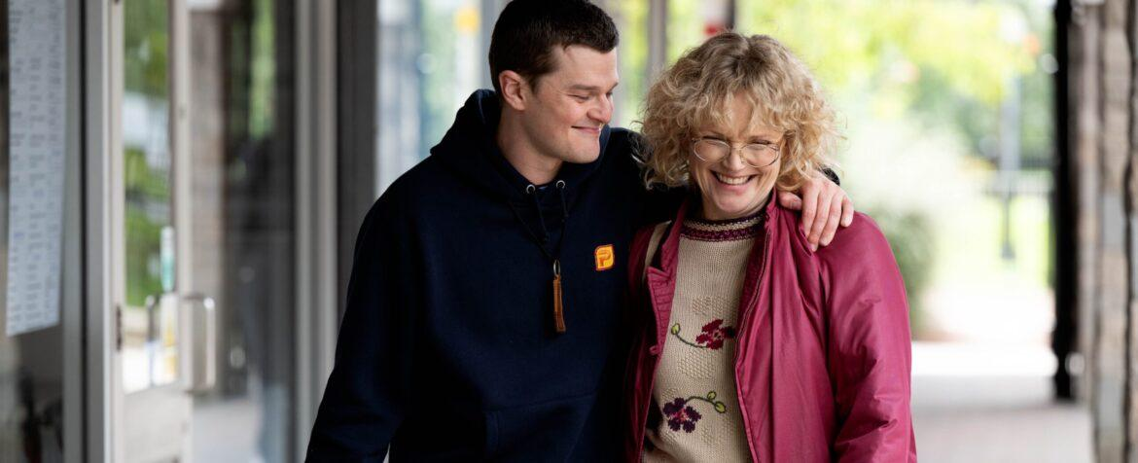

I SWEAR (2025) dir. Kirk Jones

**I SWEAR Relaxed Film Screenings**

**Various venues | October, UK**

[**I SWEAR**](https://www.youtube.com/watch?v=oeWqQN3snCU) is an upcoming Scottish drama film directed, written, and produced by Kirk Jones. The film follows the true story of John Davidson, who was diagnosed with Tourette's syndrome as a young boy during the 1980s during an era where the condition was widely unknown and misunderstood.

[You can watch the trailer here.](https://www.youtube.com/watch?v=oeWqQN3snCU)

**Cinemas across the UK** will be providing relaxed screenings for this film**.** Contact your local cinemas to find out if they’ll be providing any.

Read this [Screen Daily article](https://www.screendaily.com/features/why-authenticity-was-a-top-priority-for-the-uk-team-behind-tourette-syndrome-biopic-i-swear/5208624.article) on the film’s commitment to authenticity.

[**Scottish Queer International Film Festival 2025**](https://www.sqiff.org/)

**27 October - 1 November, Glasgow**

SQIFF 2025 returns to venues across Glasgow with a film programme that showcases queer storytelling from the LGBTQIA+ communities in Scotland and beyond.

[Oska Bright Film Festival](https://oskabright.org/) returns to SQIFF with a [short film selection](https://www.tickettailor.com/events/sqiff/1852863) programmed by Matthew Hellet. QUEER FREEDOM is a fearless, unapologetic celebration of Learning Disabled and autistic filmmakers' stories, who are reshaping cinema with their unique voices, powerful stories, and visionary perspectives.

The screening will be followed by a special conversation hosted by Stella Nicholson with Matthew Hellett.

Learn more about SQIFF’s access measures by visiting their [website’s accessibility information](https://www.sqiff.org/accessibility/).

[**Together! Disability Film Festival**](https://www.together2012.org.uk/together-2025-disability-film-festival/)

**December, Online**

Together! returns in December, coinciding with Disability History Month. The festival is currently open for submissions from Disabled filmmakers:

[Learn more about submitting a film to Together!](https://www.together2012.org.uk/together-2025-disability-film-festival/)

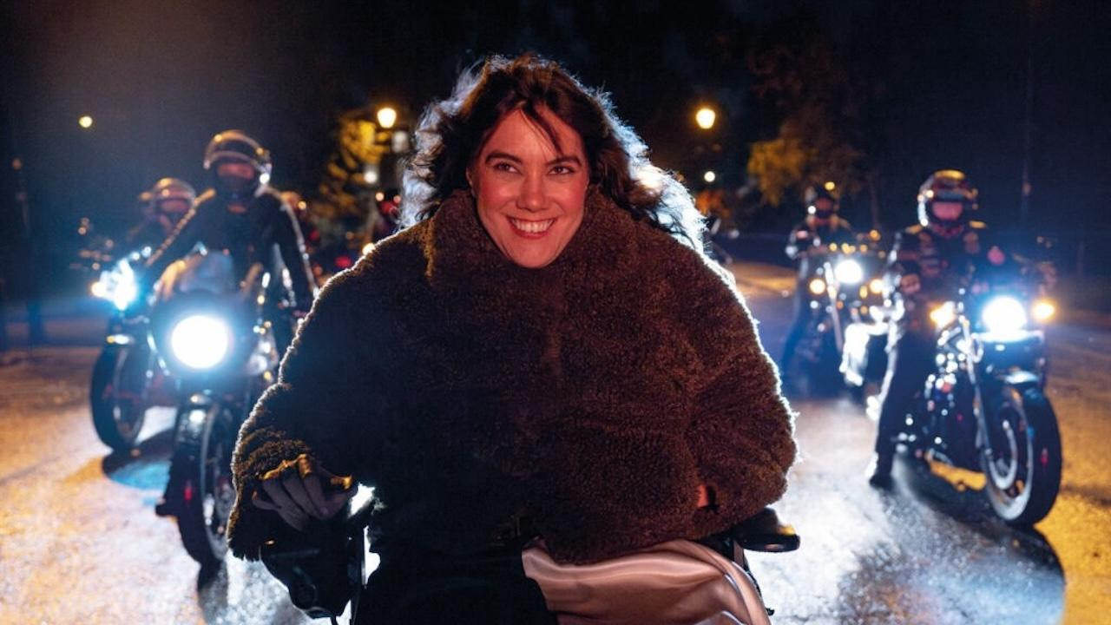

We Might Regret This *(2024) dir. Nick Collett*

[**An Audience with Kyla Harris: Cripping the Screen Industries**](https://www.youtube.com/watch?v=bSSorEcvQUo)

**Session recording | Online**

The [BFI’s We Crip Film Festival](https://whatson.bfi.org.uk/Online/default.asp?BOparam::WScontent::loadArticle::permalink=we-crip-film-festival&BOparam::WScontent::loadArticle::context_id=) took place at BFI Southbank in July to mark Disability Pride Month. The festival hosted a special, recorded conversation with Kyla Harris, Chair of the BFI’s external steering group, We Crip Film.

Kyla Harris is an award-winning writer, actor and producer. Serving many hats, their work centres intersectionality as a lens to cultivate inclusion and create connection. In 2024, Kyla co-created, co-wrote and starred in the comedy-drama series We Might Regret This. She also produced the Independent Spirit Award-nominated Patrice: The Movie, which premiered at Toronto International Film Festival and was a hit at London Film Festival last year.

Join festival co-programmer **Tara Brown** and **Kyla Harris** in conversation on what it truly means to reclaim the word “crip” and to create meaningful change in the screen industries for disabled people.

[Watch the Q&A on the BFI’s YouTube](https://www.youtube.com/watch?v=bSSorEcvQUo).

## **News and Articles**

### **[DEAF Interview](https://www.theguardian.com/film/2025/sep/08/deaf-unflinching-film-about-parenting-with-deafness)**

In this interview, the sister duo behind the upcoming Spanish drama DEAF discuss the film’s representation of motherhood, identity, and the trauma that disabled mothers can experience in an ableist and inaccessible society.

[Guardian article — ‘If something goes wrong in childbirth, how will I know?’ The unflinching film about parenting with deafness](https://www.theguardian.com/film/2025/sep/08/deaf-unflinching-film-about-parenting-with-deafness)

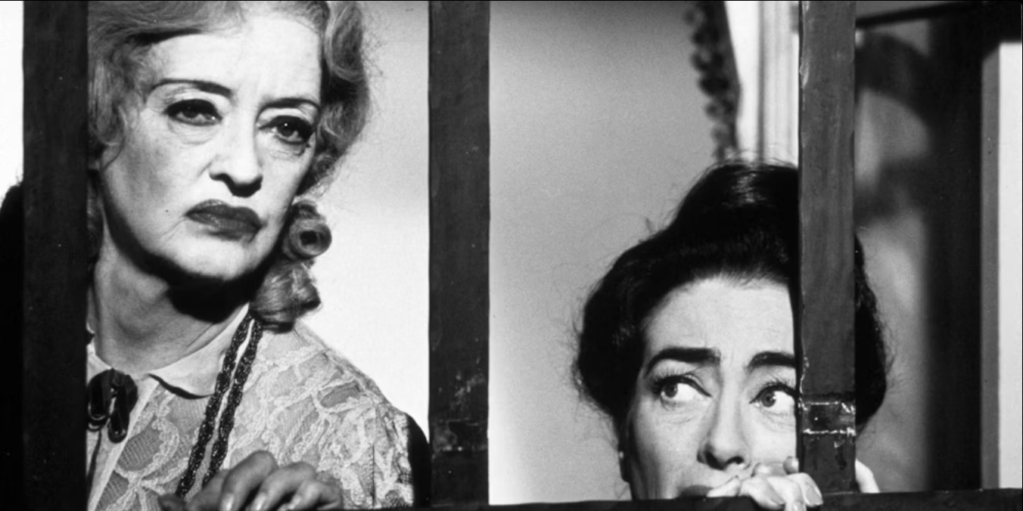

What Ever Happen to Baby Jane? (1962) dir. Robert Aldrich

[**STIM Collective: ‘What What Ever Happened to Baby Jane (1961) gets right about disability’**](http://stims.substack.com)

**Essay | Read online**

In this essay, STIMS Collective co-founder Georgia Kumari Bradburn revisits the camp thriller as a herald of progressive attitudes towards disability and mental health.

Read [‘What What Ever Happened to Baby Jane (1961) gets right about disability’ essay here.](http://stims.substack.com)

**Access Fuckery Podcast**

Access Fuckery is ‘a safe space for folks from the disability community to rant, rave, and vent about failures in access, and discuss what can and should be done about it.’

The latest podcast episode focuses on cinema’s provision of audio description with guest speakers from The Blind Film Critics Society.

Listen to [‘The Blind Film Critics Society on Cinema Fuckery’ podcast episode](https://accessf-ckery.podbean.com/e/the-blind-film-critics-society-on-cinema-fuckery/) on the website. There are also transcripts available for episodes.

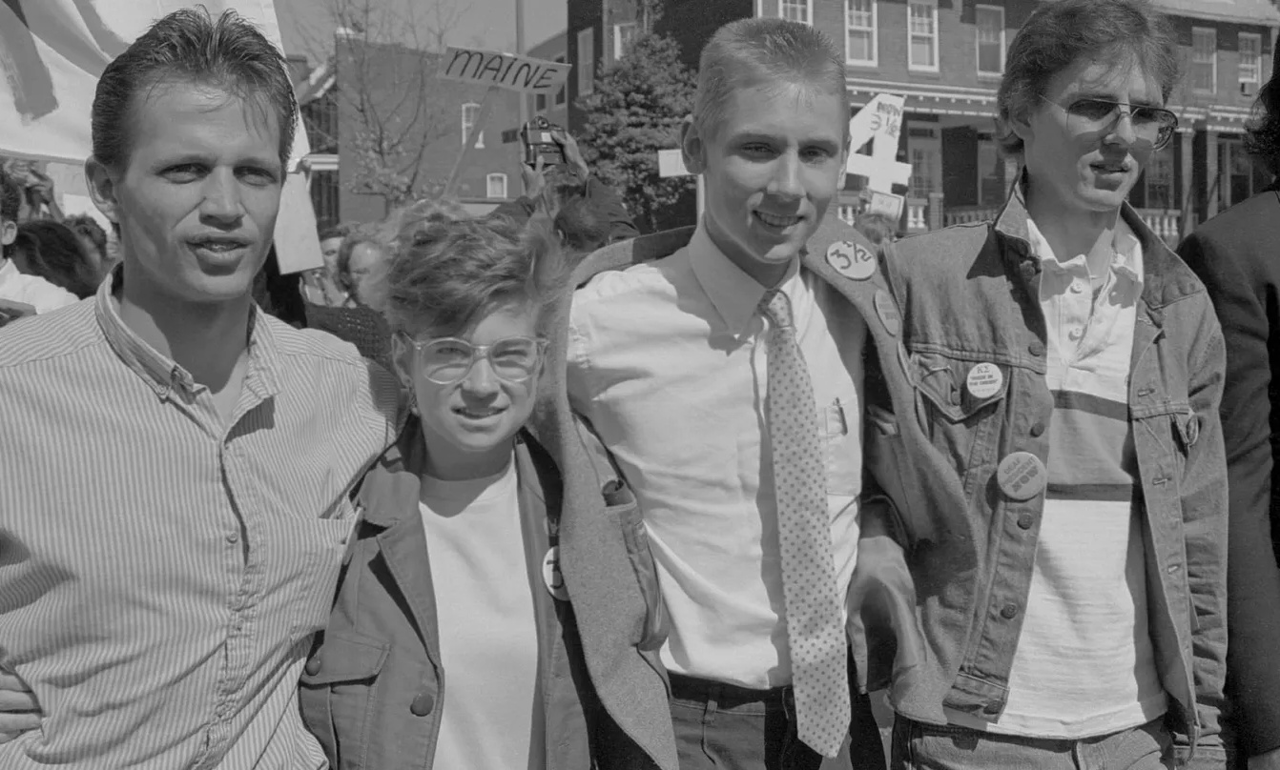

Deaf President Now! (2025) dir. Nyle DiMarco and Davis Guggenheim

[**‘Why Are Disabled Journalists Still Not Covering Disabled Content?’ Article**](https://thefilmmaven.substack.com/p/deaf-president-now-documentary-disabled-journalists)

In the aftermath of Apple TV’s release of DEAF PRESIDENT NOW, disabled film journalist Kristen Lopez explores the lack of Deaf and disabled representation within film criticism and journalism.

Read her article on [The Film Maven’s Substack.](https://thefilmmaven.substack.com/p/deaf-president-now-documentary-disabled-journalists)