Sir Hedworth Williamson (Liberal Party Candidate)

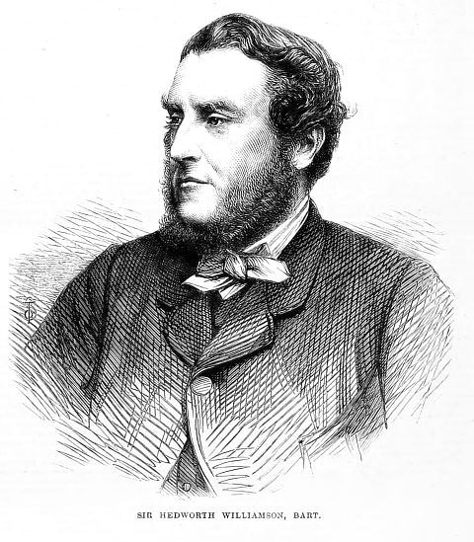 | Title: 8th Baronet of East Markham  Born: 25th March 1827  Home: Whitburn Hall, Whitburn Near Sunderland, County Durham  Education: Eton and then Oxford and Cambridge  Experience: Diplomat in St. Petersburg, Russia and Paris, France; Justice of the Peace (Magistrate) in County Durham; Captain Commandant of the 1st Durham Volunteer Artillery (honorary position)  Incumbent (first elected 1864, re-elected 1865)

Background:
Sir Hedworth Williamson comes from a wealthy, upper-class, land-owning family. His father, also called Sir Hedworth Williamson (7th Baronet of East Markham) had also been a Liberal MP for Durham.

Sir Hedworth Williamson’s 1868 campaign:
- Primary aim is to keep the seat he first won in the 1864 by-election. He would highlight his incumbency to voters

- Highlighting the success of liberalism and their leaders (current leader William Gladstone) and the popularity of liberal candidates throughout constituencies in County Durham in the election

- In support of giving the Irish more religious freedom by removing the Protestant Church of Ireland as the official religion of Ireland.

Mr Issac Lowthian Bell (Liberal Party Candidate)

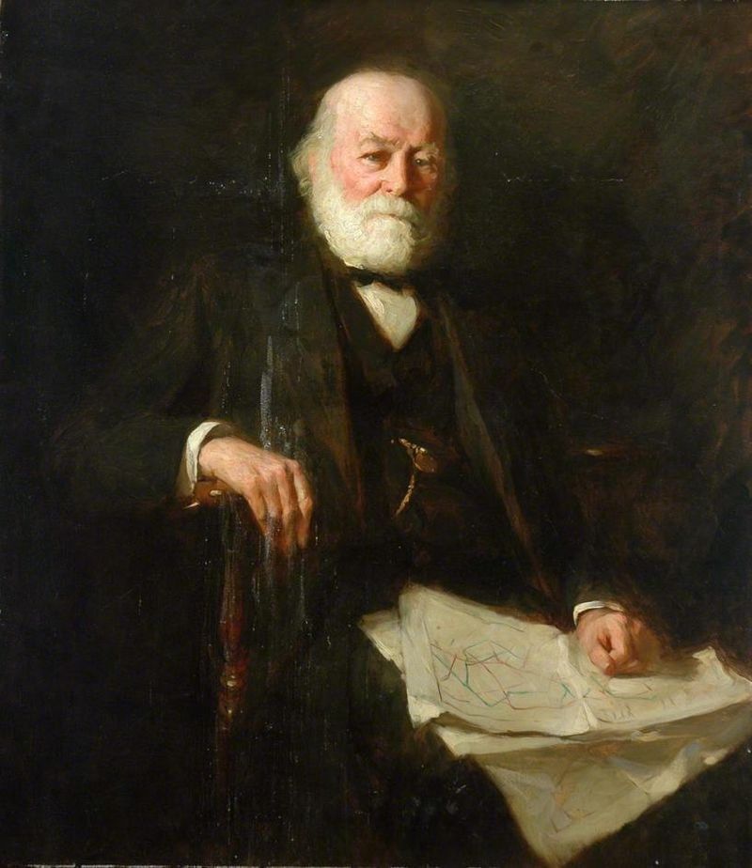 | Born: 18th February 1816 in Newcastle  Home: Washington New Hall, Washington, Sunderland  Education: Newcastle, Edinburgh University and Sorbonne in Paris, where he studied chemistry and metallurgy  Experience: Industialist (founder of the first UK factory to manufacturing aluminium in the 1850s); largest owner of coal mines in South Durham; Mayor of Newcastle (1854-5 and 1862-3); Justice of the Peace (Magistrate) in County Durham; Fellow of the Royal Society and author scientific papers and books

Background:
Mr Isaac Lowthian Bell comes from a middle-class background that had become wealthy in the Industrial Revolution. His father had been a partner in a newly set up iron processing factory in Newcastle.

Mr Issac Lowthian Bell’s 1868 campaign:

- Running to secure the second seat for the Liberal Party next to Sir Hedworth Williamson (the incumbent running for re-election). Since the last election North Durham had been represented by two Liberal MPs.

- Great proponent of the liberal principle of free trade (= letting industries govern themselves without government involvement via rules and regulations and taxation). Believes that liberalism best suited to create prosperity for all.

- In support of giving the Irish more religious freedom by removing the Protestant Church of Ireland as the official religion of Ireland.

Mr George Elliot (Conservative Party Candidate)

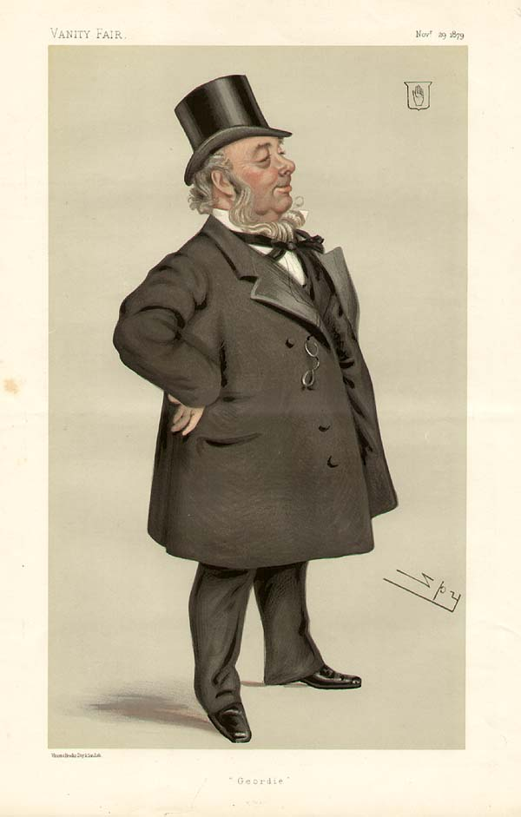 | Born: 18th March 1814 in Gateshead  Home: West Rainton (also has a house in 17 Portland Place, London)  Education: Limited formal schooling; taught himself mathematics in his spare time  Experience: Started work as trapper boy (= opening the doors for the miners with their tubs) in the Whitfield colliery at 9; worked as coal miner at various levels until he was 20, thereafter worked in the surveyor’s office in Newcastle; put in charge of the colliery at Monkwearmouth with 24; leased his own mine and by 1864 owned several mines in County Durham and South Wales.

Background:
Mr George Elliot was born into a working-class mining family with limited means and worked his way to wealth (i.e., a self-made man). Aside from owning coal mines, he worked towards improving mining conditions (e.g., helped draw up the Mines Regulation Act of 1860; member of the Royal Commissions on Coal Supply and Accidents in Mines). Other business interests included a company that made Telegraph cables. Since 1856 he served as member of the Institute of Civil Engineering.

Mr George Elliot’s 1868 campaign:

- Aims to re-gain a seat for the Conservative party in North Durham (last Conservative MP for North Durham was Lord Adolphus Vane-Tempest (1952-64), when he died – one of his Liberal opponents, Sir Hedworth Williamson, won that seat unopposed in 1864).

- Supporter of traditional British values and society – Queen Victoria, the Church of England, and the House of Lord. The key principles of the Conservative party in 1868 was to keep things as they are without further change (e.g., he is against further extending the franchise).

- Regarding the status of the Church of Ireland, Mr. Elliot believes it should remain the official church, making Protestantism the official religion of Ireland.

