Coal Mining and Local History
An Investigation of the Death of James White
Teachers’ Resource
Links with the Curriculum Key Stage 2
History- Pupils should develop a chronologically secure knowledge and understanding of British, local and world history, establishing clear narratives within and across the periods they study. They should note connections, contrasts and trends over time and develop the appropriate use of historical terms. They should regularly address and sometimes devise historically valid questions about change, cause, similarity and difference, and significance. They should construct informed responses that involve thoughtful selection and organisation of relevant historical information. They should understand how our knowledge of the past is constructed from a range of sources.
Local History - A study of an aspect of history or a site dating from a period beyond 1066 that is significant in the locality.
English - Reading Comprehension Yr 3/4 - retrieve and record information from non-fiction texts – in using non-fiction pupils should know what information they need to look for before they begin and be clear about the task. Yr 5/6 – retrieve, record and present information from non-fiction. The skills of information retrieval should be applied in reading history texts.
Geography – to ensure that all pupils are competent in geographical skills needed to interpret a range of sources of geographical information including maps, diagrams and aerial photographs.

List of start-up resources:
- James White Memorial Card
James died in an accident at South Hetton Colliery in 1867 and this card forms the basis of the whole resource and investigative activity at the Museum. Students will see this for the first time at the start of the activity based in the Chapel in the Pit Village, they will need to find out what happened and decide what should change at the mine so that accidents like this do not happen again. The card can be used back in the classroom once the students have done the activity.
- Census for the White Family in 1861
This gives the children a context for what is going to happen to the family in the coming years. This can be shared with the children before they visit the Museum and information about them described. Each dwelling has two rooms. Note the number of miners, children going to school as scholars, the diverse places of where people were born.
- Census for the family in 1871
This shows the children what happened to the family after the accident. This can be explored after the visit to the Museum.
- Work sheet for the 1871 census

- Original Census for the White Family 1861 and 1871
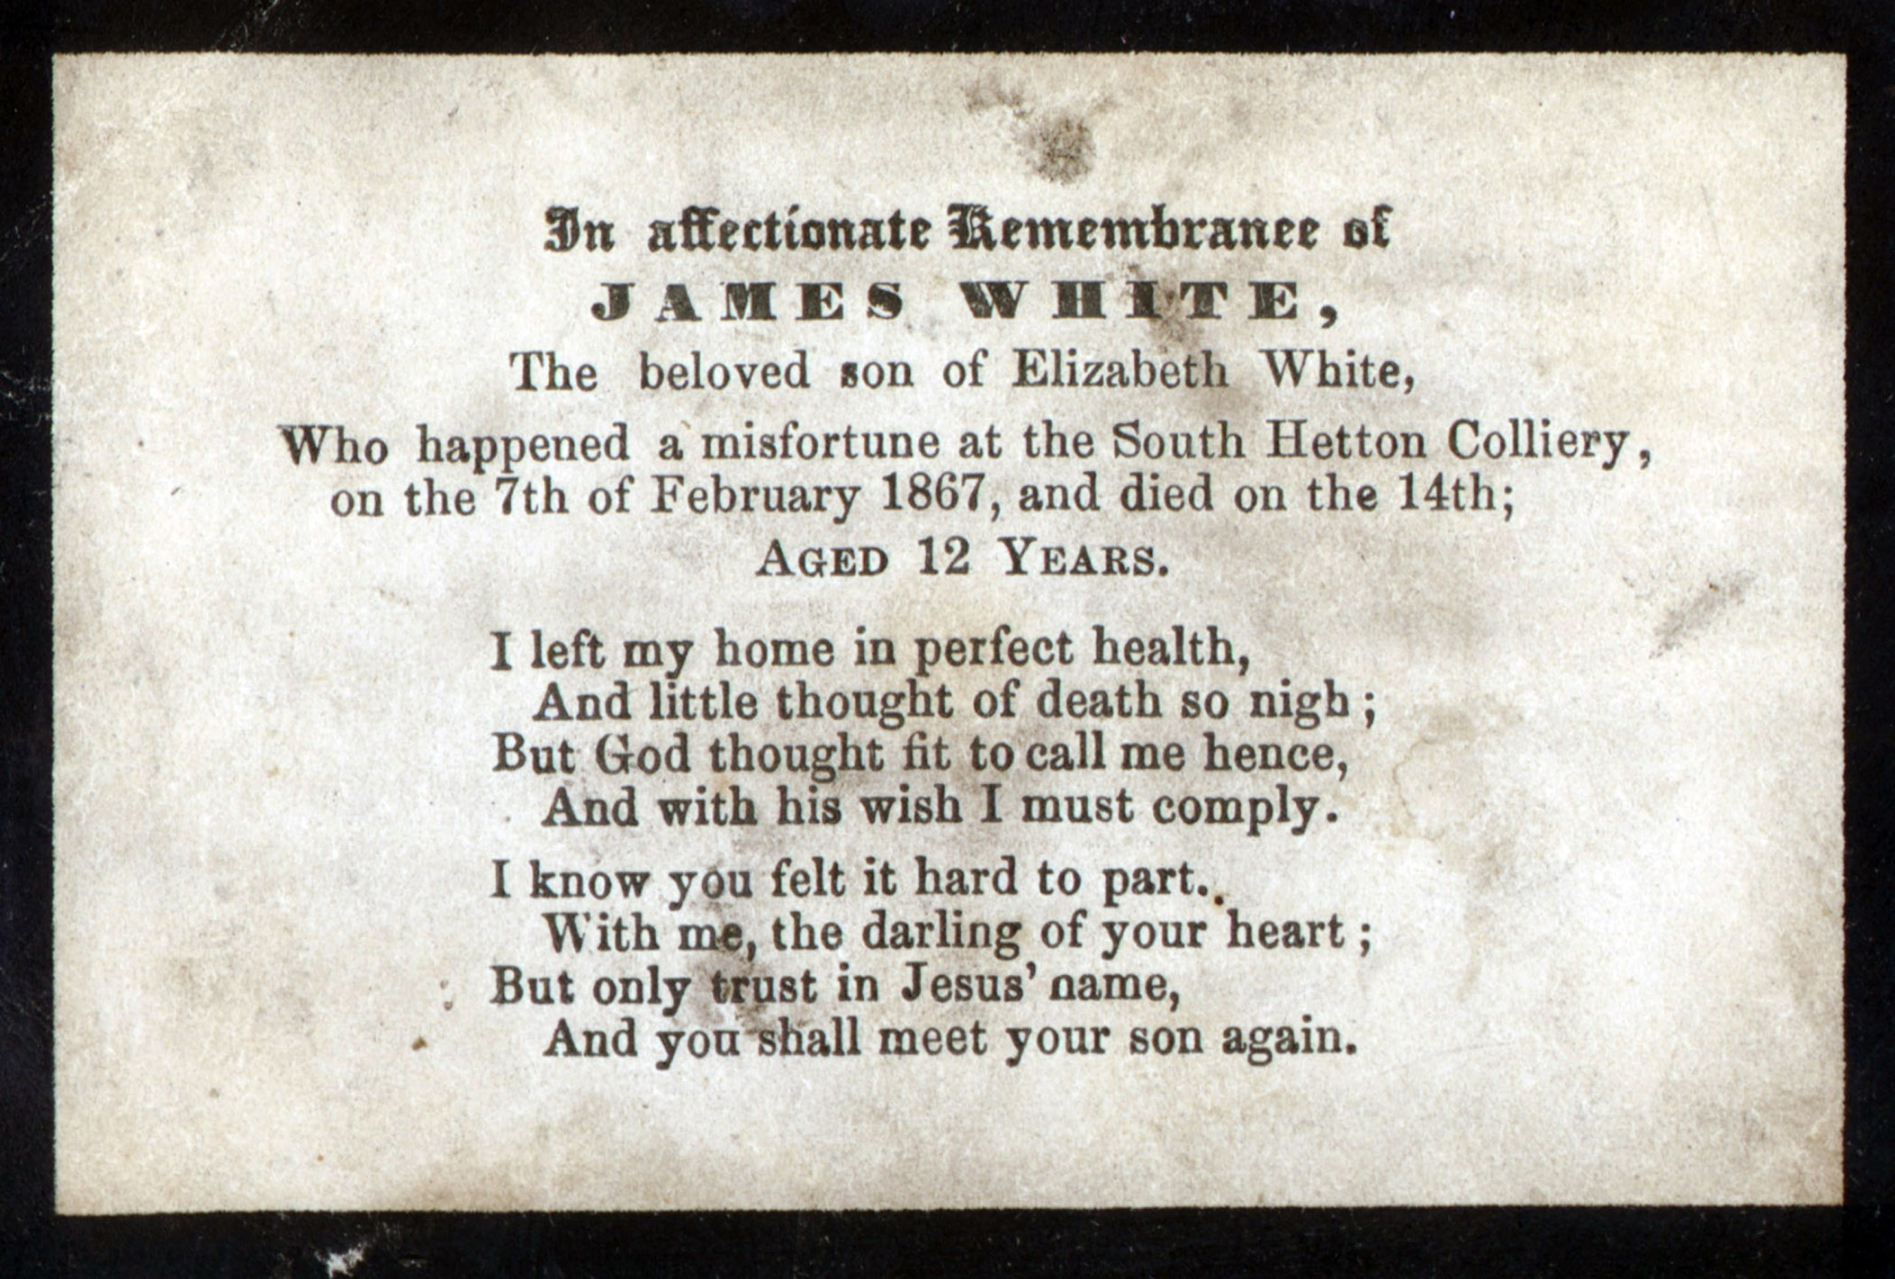

Census for Newbottle – Houghton le Spring 1861
Address | Name | Relation | Age | Male/  Female | Job | Place of Birth
Philadelphia  Prud. Dwellings | William Toward | Head | 31 | M | Coal Miner | Whitehaven, Cumberland
 | Elizabeth Toward | Wife | 31 | F |  | Toft Hill, Durham
 | George Toward | Son | 5 | M | Scholar | Sunny Brow, Durham
 | Mary Toward | Daug | 3 | F |  | Beamish, Durham
 | Elizabeth Toward | Daug | 1 | F |  | Benton, Northumberland
Philadelphia  Prud. Dwellings | John White | Head | 35 | M | Coal Miner | Ponteland, Northumberland
 | Elizabeth White | Wife | 33 | F |  | Seghill, Northumberland
 | James White | Son | 6 | M | Scholar | Monkwearmouth, Durham
 | Margaret White | Daug | 2 | F |  | Eighton Banks, Durham
 | Charlotte H. White | Daug | 6 m | F |  | Birtley, Durham
Philadelphia  Prud. Dwellings | George Horn | Head | 33 | M | Iron Forgeman | Houghton le Spring
 | Mary Horn | Wife | 33 | F |  | Durham
 | Michael Horn | Son | 9 | M | Scholar | Houghton le Spring
 | Eleanor Horn | Daug | 7 | F | Scholar | Newbottle, Durham
 | Dorothy Horn | Daug | 5 | F | Scholar | Hartlepool, Durham

Haswell – South Hetton 1871- Front Street
Address | Name | Relation | Age | Male/  Female | Job | Place of Birth
8 | Edward Richardson | Head | 45 | M | Blacksmith | Northumberland
 | Jane Richardson | Wife | 48 | F |  | Durham
 | Edward Richardson | Son | 16 | M | Engine fitter at coal mine | Northumberland
 | Jane A Richardson | Daug | 15 | F | Scholar | Northumberland
 | Thomas Richardson | Son | 13 | M | Coal miner | Northumberland
 | Robert Richardson | Son | 12 | M | Scholar | Northumberland
 | Harrison Richardson | Son | 8 | M | Scholar | Northumberland
 | George Richardson | Son | 6 | M | Scholar | Northumberland
 | Mary Richardson | Daug | 4 | F |  | Northumberland
 | Sarah Richardson | Daug | 3 | F |  | Northumberland
9 | Thomas Bowdon | Head | 65 | M | Coal miner | Newcastle upon Tyne
 | Mary Bowdon | Wife | 52 | F |  | South Hetton
 | Thomas Bowdon | Son | 23 | M | Coal miner | South Hetton
 | William Bowdon | Son | 18 | M | Coal miner | South Hetton
 | John Allinson | Gr. son | 5 | M | Scholar | Sunderland
10 | Joseph Hetherington | Head | 45 | M | Coal miner | Gateshead
 | Elizabeth Hetherington | Wife | 43 | F |  | Seghill, Northumberland
 | Margaret White | Step Dau | 12 | F | Scholar | Eighton Banks, Durham
 | Charlotte H. White | Step Dau | 10 | F | Scholar | Birtley, Durham

South Hetton
Name ________________________
Questions about the 1871 census

- How old was Mary Richardson?
_________________________________
- Where did Joseph Hetherington live?
_________________________________
- How many males lived at 8 Front Street?
_________________________________
- What was Edward Richardson’s job?
_________________________________
- How many children lived at 8 Front Street?
_________________________________
- How many people were called Thomas?
_________________________________
- Where was Mary Bowden born?
_________________________________
- Who is the oldest person on the census?
_________________________________

- Who is 13 years old?
_________________________________
- What can you say about John Allinson?
_________________________________
- How many people on this census worked at the coalmine?
_________________________________
- What do you think Robert Richardson will do when he leaves school?
_________________________________
- What do you think Jane A Richardson will do when she leaves school?
_________________________________
- If the Richardsons have three rooms in their house. Where do they all sleep?
________________________________________________________________________________________________________________________
- Why do you think there is no one over 65 years old?______________________________________
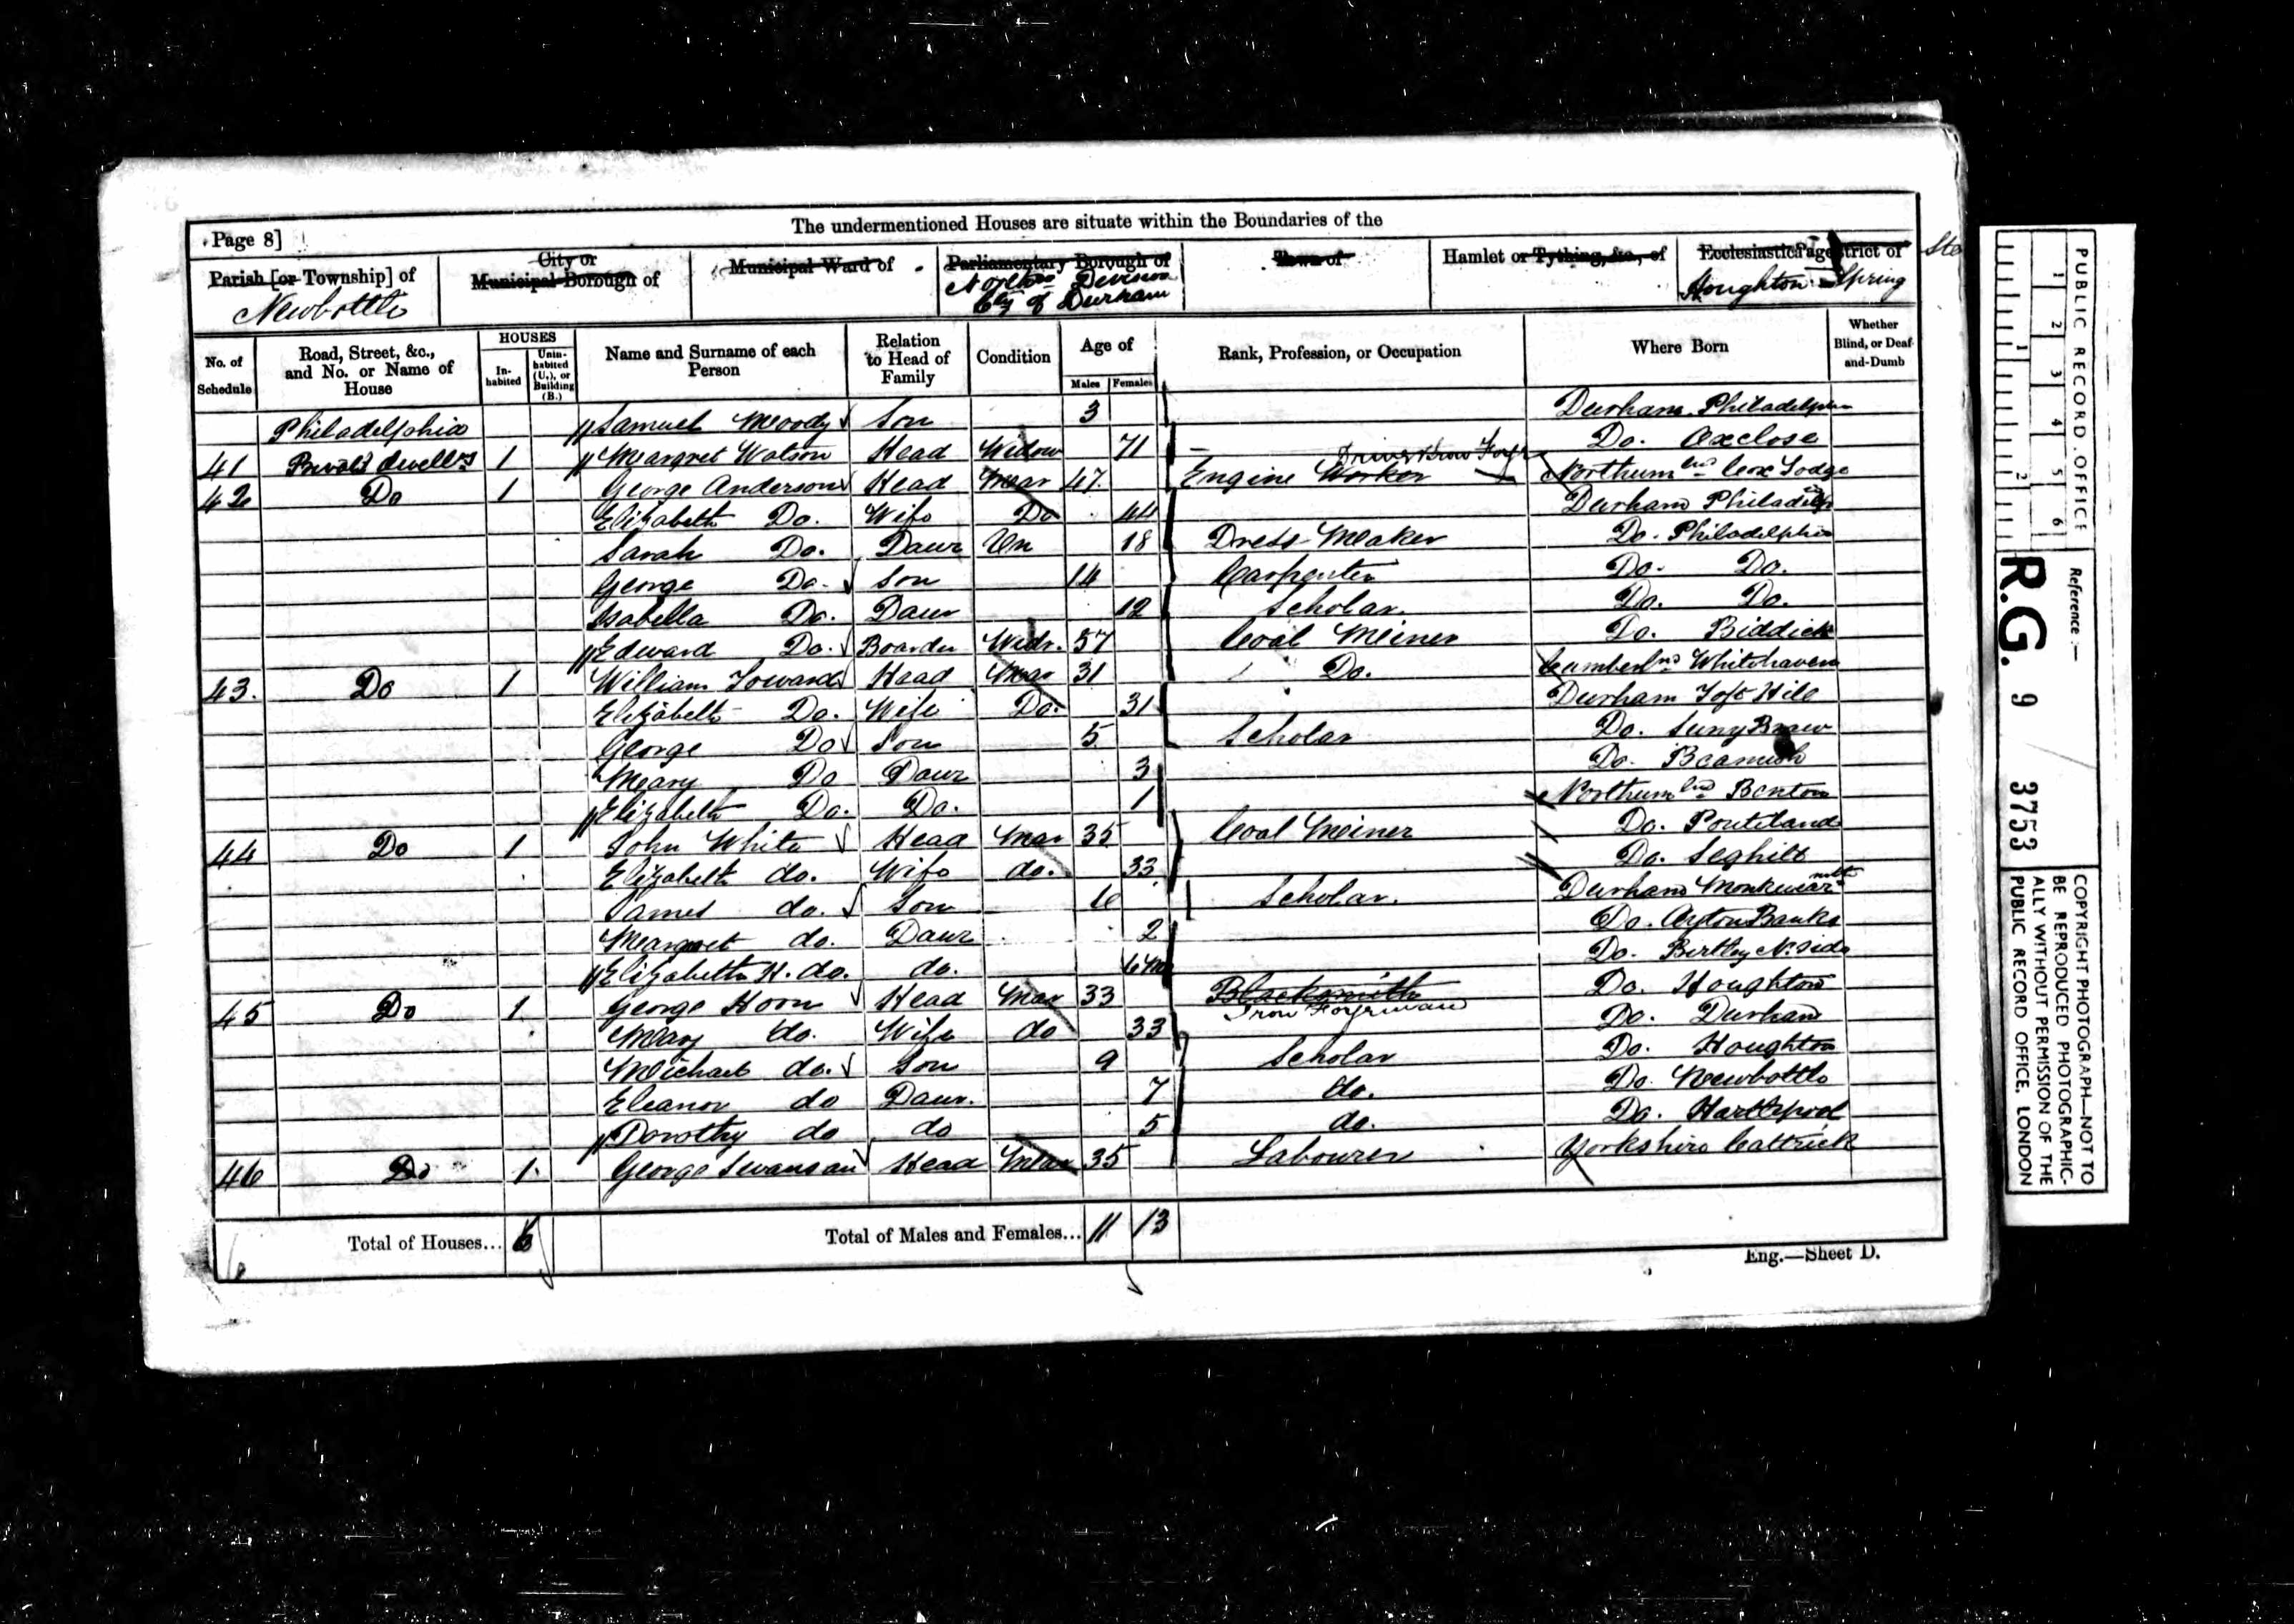

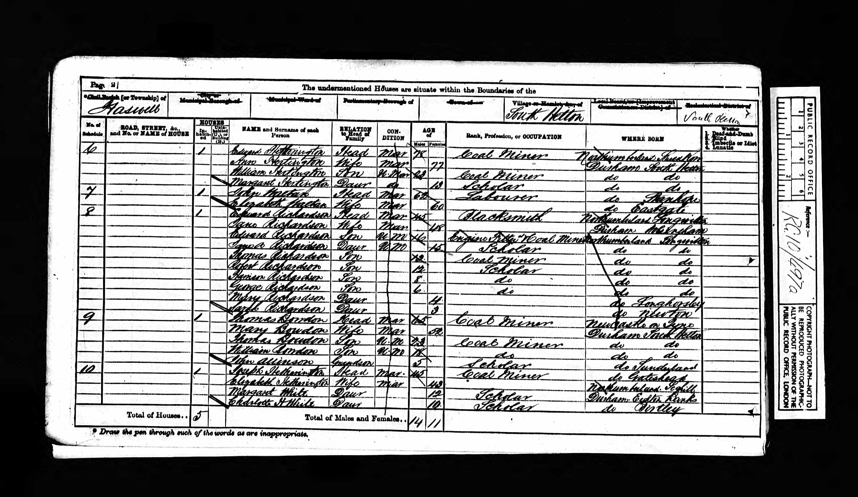

Coal Mining and Local History
An Investigation of the Death of James White
Teachers’ Resource
List of mapping resources
- Map of South Hetton showing the Colliery and the surrounding landscape and village. There are some significant things to draw the children’s attention to.
- The business of the coal mine: the railways to take the coal away to the ports to load the ships to transport the coal to the major markets particularly London; the Pit Heap marked with stony looking ground, anything that was not coal was dumped here; the reservoirs took the dirty water that collected in the tunnels it was pumped out of the mine so that the miners were not working in meters of water; the gasometer which was used to collect the methane gas from the mine (dangerous underground because of its tendency to cause explosions but worth while collecting to sell for street lights).
- The structure of the village and the home environment: children could look for the schools, churches, and chapels, pubs; the houses, look at the eight streets to the north of the station their toilets are between the houses, the post office (P.O.) and the Literary Institute (funded by the miners themselves).
- Question sheets linked to the map.
- Aerial view of South Hetton showing Colliery. Children can match up the aerial photograph with the map.
Map of South Hetton in the 1890s

Name _________________________
South Hetton Map
- Colour in the stony looking ground. What do you think this could be?
________________________________________________________________________________
- Find the allotment gardens. Why do you think the gardens are not next to the houses?
________________________________________________________________________________
- Mark the railways on the map. Why do you think there are so many?
________________________________________________________________________________

- Find five things that are marked on the map that are likely to be still there today:
  - _____________________________
  - _____________________________
  - _____________________________
  - _____________________________
  - _____________________________

- Find five things that are marked on the map that are likely to have now disappeared:
  - ______________________________
  - ______________________________
  - ______________________________
  - ______________________________
  - ______________________________

Find and colour the following:
- Reservoir
- Holy Trinity Church
- Grey Horse Inn
- Station
- Gasometer
- School
- Old quarry
- Methodist Chapel
- Post Office
- Pub
- Signal Box
- Mile Post
- Sewage tanks
- Foot Bridge
- Shaft
- Literary Institute
- Coal Depot

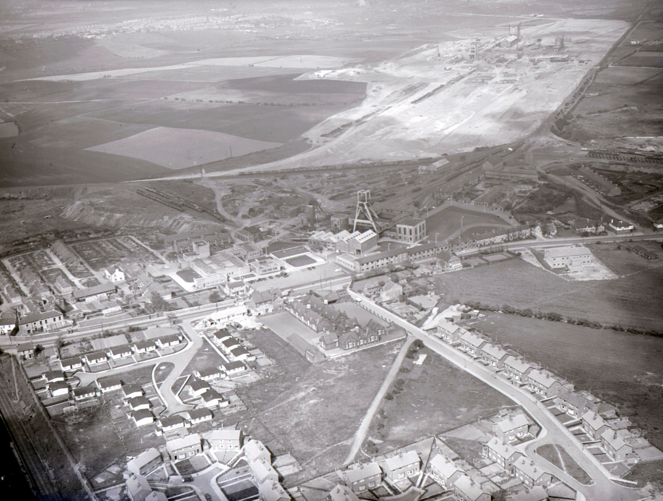
Coal Mining and Local History
An Investigation of the Death of James White
Teachers’ Resource
List photographic resources
- Photographs of the Coal Mine
  - Illustration from The Penny Magazine supplement of the Society for the Diffusion of Useful Knowledge, depicting South Hetton Colliery in 1835 showing Pit Head Works, Steam Winding Engine House, evidence of horse operation and pit heap.

  - General view of pit head at South Hetton Colliery, c1910. Showing railway operation with coal wagons, winding house, pit wheels and railway points.

  - Group of Officials at Hetton Colliery, 1900. Note managers usually had white collars, the men in front holding deputy sticks and safety lamps as a mark of their rank (and use) and generally formal clothes completely different from ordinary mine workers.

- Work on the screens at the surface
  - The picking belts at St. Hilda's Colliery, South Shields in 1901. Note the deputy on the higher level monitoring the work of the pickers with his very long stick, the mix of the very young and the very old and the gentleman with only one arm on the right hand belt.

  - Picking belt, where a quantity of stone has been thrown off the belt on to the floor. Note the very young, it was said you started on the belts and finished on the belts. Anything that was not coal was thrown behind as the belts trundled along, coal dropped into the wagons at the end of the belt.

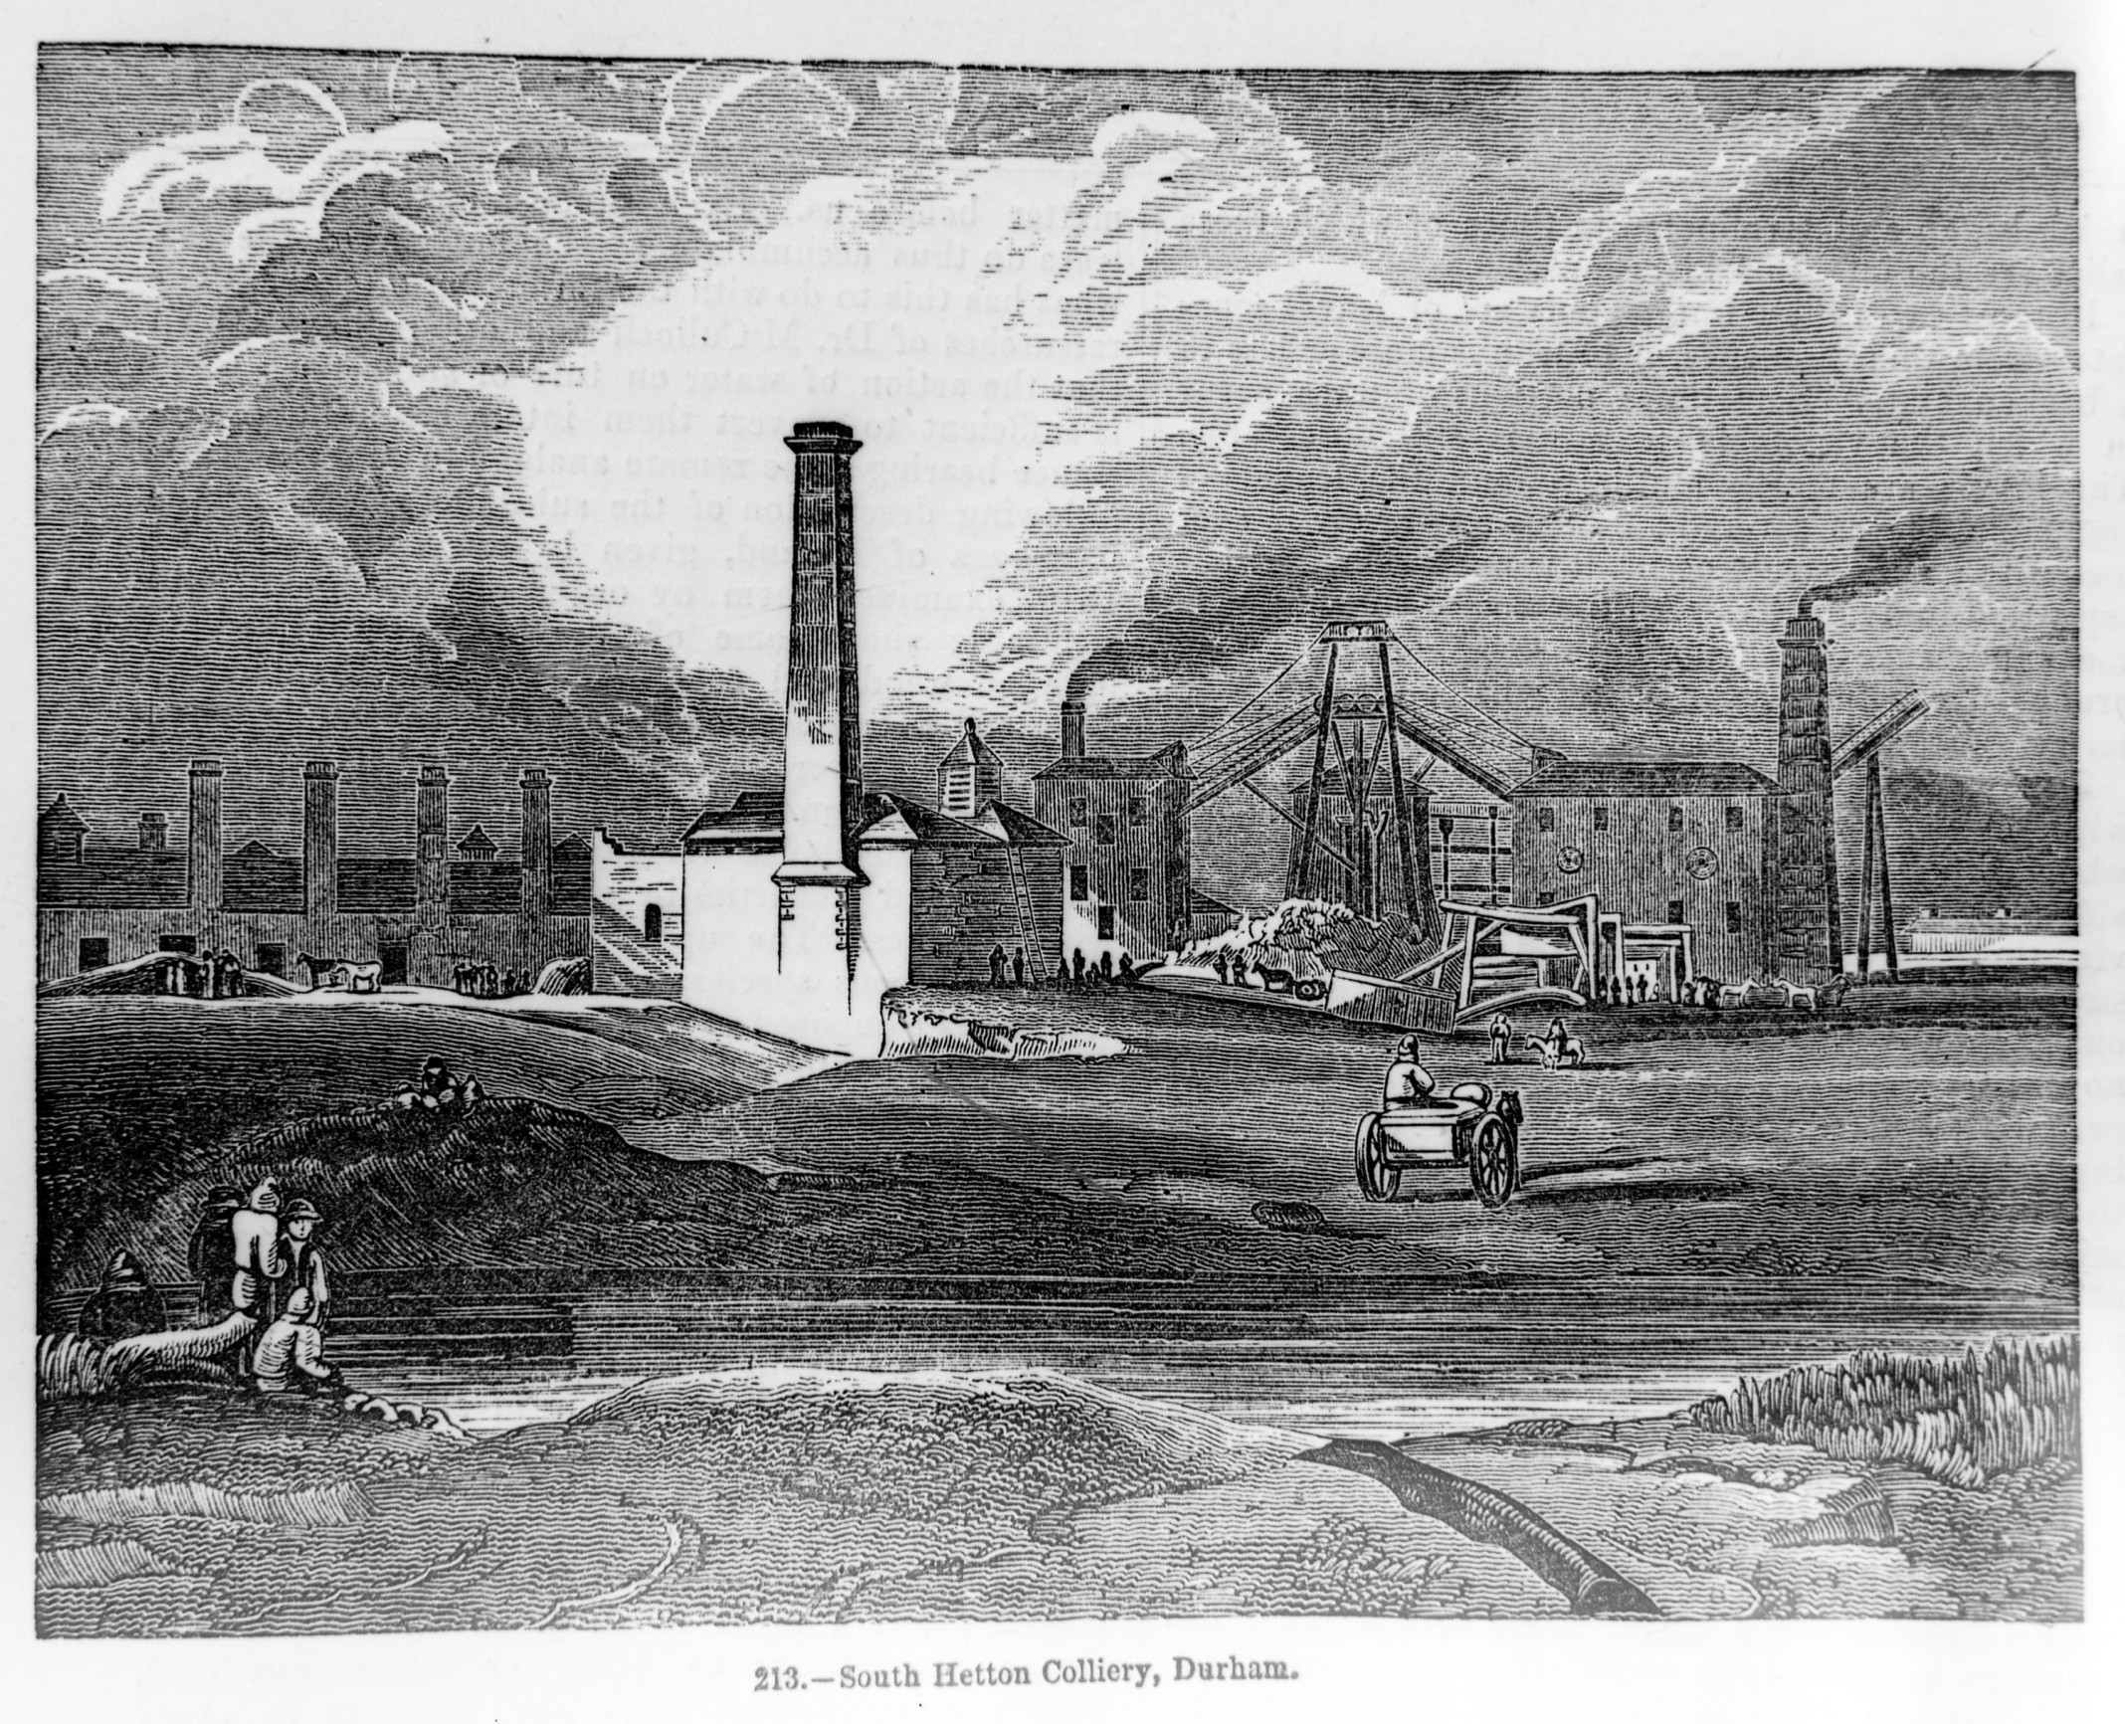
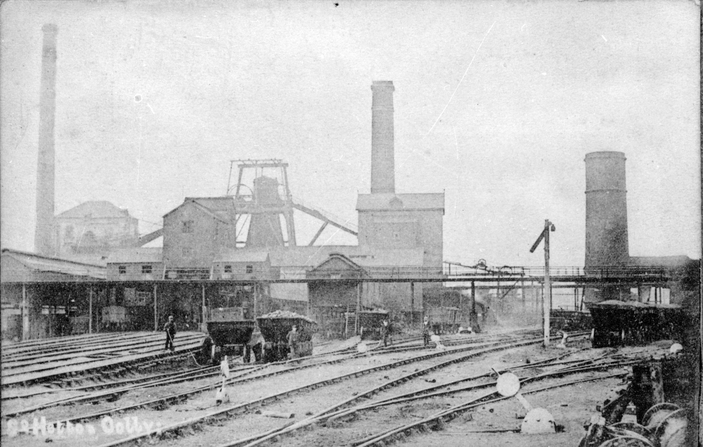

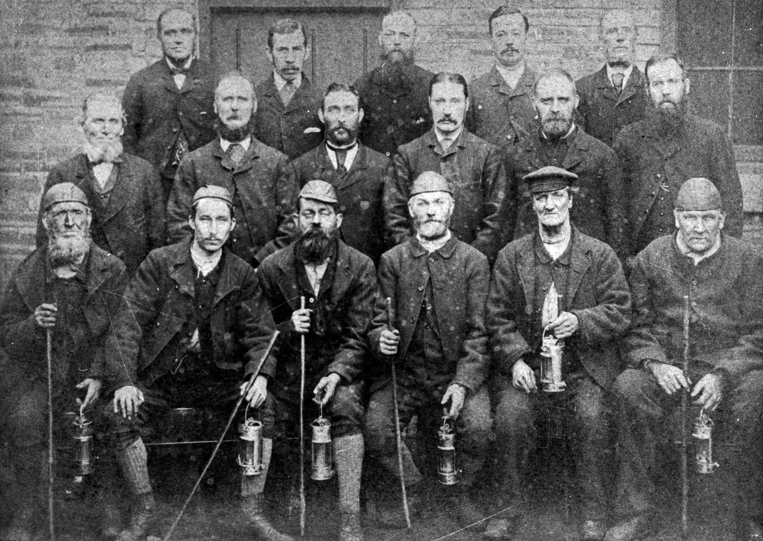
Coal Mining and Local History
An Investigation of the Death of James White
Teachers’ Resource
- List specific resources relating to the James White Story
What is a Wailer?

Wailer 1825

Boy employed to pick out slate, pyrites, and other foul admixtures from the coal.

Wailer 1849

Boy employed in waggons to pick out any stones or pyrites which have escaped the observation of the skreenmen.

Notice of accident for James White
White, James, 07 Feb 1867, aged 12, Wailer, crushed by small coal apparatus tub; he ought not to have been in the hole

Notice of accident for John White (James’s father)
White, John, 07 Nov 1863, aged 38, Hewer, crushed by tub in self acting plane

Coal Mining and Local History
An Investigation of the Death of James White
Teachers’ Resource
List photographic resources

- Image of Wailer working in Chauldron
Illustration from The Penny Magazine supplement of the Society for the Diffusion of Useful Knowledge, February 28-31, 1835, p128, depicting screening coal into chauldron wagons at South Hetton Colliery. Note the worker standing in the chauldron as the coal arrives. It was James’s job to extract the stone that was not coal from the chauldron. This is what he was doing when someone released to the coal from the belts above.
- Hetton Colliery locomotive, 1870's or 80's.
This original engine can be found at the Waggonway at the Museum. It is on loan from the National Railway Museum. It is no longer operational. Note the driver and the fireman, the vertical cylinder system to drive the wheels, the water tank being pulled behind, the stack and the points for the rails. This engine was in use before George Stephenson built Locomotion for the Stockton to Darlington line in 1825. These engines were used to transport the coal from the collieries to the harbours at Seaham and Sunderland.
- General view of Front Street, South Hetton.
This image was taken in black and white and then painted over using water colours. It was taken from the railway station at South Hetton looking west up Front Street. Two pubs can be picked out on the right of the street with the Methodist Chapel on the left. Note the children standing in the street and one riding a horse with no other traffic and the pram on the right with two babies in bonnets. How life has changed!
- and 16. School group photograph at South Hetton School Class 7, c1920 with Lydia and Gerty Short marked on the photo and Group of boys in their school classroom, possibly South Hetton.
Compare and contrast the images we have today of groups of children in their school. Note the hair styles and one boy in the girl image and the children’s shoes. The boys shown in the classroom is very similar to the classroom in the Board School at Beamish particularly with partition.

