
Examination
Information

For Students
2025 - 2026






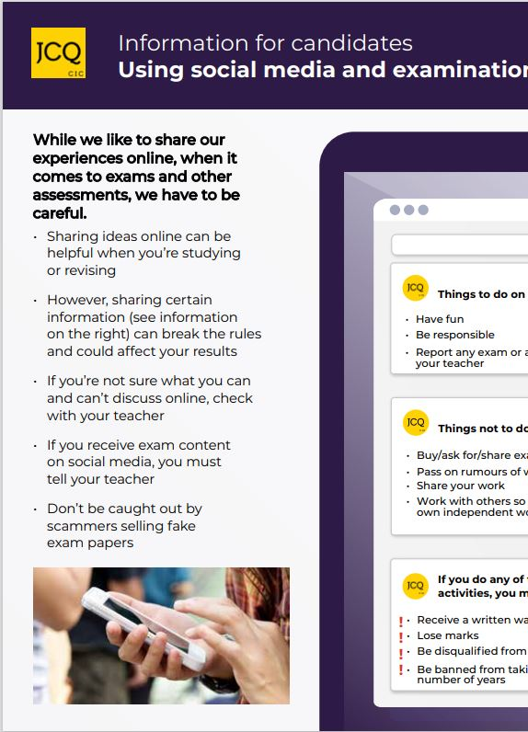

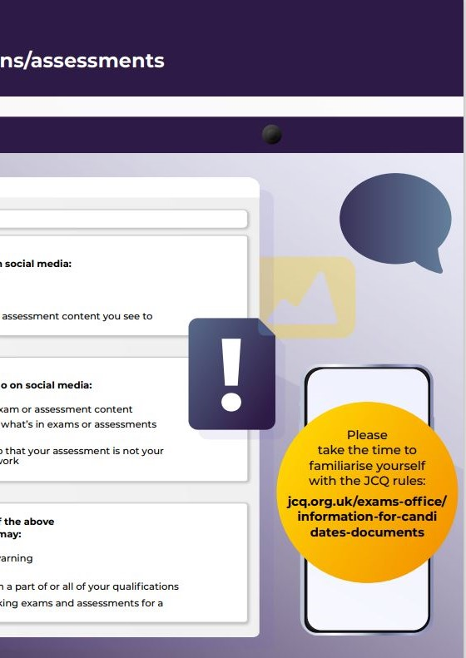

Information for Candidates
For Written Examinations
This document has been written to help you. Read it carefully and follow the instructions.
If there is anything you do not understand, especially which calculator you may use, ask your teacher.

A. Regulations – Make sure you understand the rules
- Be on time for all your exams. If you are late, your work might not be accepted.
- Do not become involved in any unfair or dishonest practice during the exam.
- If you try to cheat, or break the rules in any way, you could be disqualified from all your subjects.
- You must not take into the exam room:
- notes;
- Airpods, earphones/earbuds, an iPod, a mobile phone, a MP3/4 player or similar device, a watch, smart glasses , tablet or any other smart device.
Any pencil cases taken into the exam room must be see-through.
Remember: possession of unauthorised material is breaking the rules, even if you do not intend to use it, and you will be subject to penalty and possible disqualification.
- If you have a watch, the invigilator will ask you to hand it to them.
- Do not use correcting pens, fluid or tape, erasable pens, highlighters or gel pens in your answers.
- Do not talk to or try to communicate with, or disturb other candidates once you have entered the exam room..
- You must not write inappropriate, obscene or offensive material
- If you leave the exam room unaccompanied by an invigilator before the exam has finished, you will not be allowed to return.
- Do not borrow anything from another candidate during the exam.
B. Information – Make sure you attend your exams and bring what you need
- Know the dates and times of all your exams. Arrive at least ten minutes before the start of each exam.
- If you arrive late for an exam, report to the invigilator running the exam.
- If you arrive more than one hour after the published starting time for the exam, you may not be allowed to take it.
- Only take into the exam room the pens, pencils, erasers and any other equipment which you need for the exam.
- You must write clearly and in black ink. Coloured pencils or inks may only be used for diagrams, maps, charts, etc. unless the instructions printed on the front of the question paper state otherwise.

C. Calculators, dictionaries and computer spell-checkers
- You may use a calculator unless you are told otherwise.
- If you use a calculator:
  - make sure it works properly; check that the batteries are working properly;
  - clear anything stored in it;
  - remove any parts such as cases, lids or covers which have printed instructions or formulae;
  - do not bring into the exam room any operating instructions or prepared programs.
- Do not use a dictionary or computer spell checker unless you are told otherwise.
D. Instructions during the exam
- Always listen to the invigilator. Always follow their instructions.
- Tell the invigilator at once if:
  - you think you have not been given the right question paper or all of the materials listed on the front of the paper;
  - the question paper is incomplete or badly printed,
  - you think you have not been given the expected access arrangements.
- Read carefully and follow the instructions printed on the question paper and/or on the answer booklet.
- Do not start writing anything until the invigilator tells you to fill in all the details required on the front of the question paper and/or the answer booklet before you start the exam. Do not open the question paper until you are instructed that the exam has begun.
- Remember to write your answers within the designated sections of the answer booklet.
- Do your rough work on the proper exam stationery. Cross it through and hand it in with your answers.
Make sure you add your candidate details to any additional answer sheets that you use, including those for rough work.
E. Advice and assistance
- If on the day of the exam you feel that your work may be affected by ill health or any other reason, tell the invigilator.
- Put up your hand during the exam if:
  - you have a problem and are not sure you should do;
  - you do not feel well;
  - you need more paper.
- You must not ask for, and will not be given, any explanation of the questions.
F. At the end of the exam
- If you have used more than one answer booklet and/or any supplementary answer sheets, place them in the correct order.
Place any loose additional answer sheets inside your answer booklet. Make sure you add your candidate details to any additional answer sheets that you use.
- Do not leave the exam room until told to do so by the invigilator.
- Do not take from the exam room any stationery. This includes the question paper, answer booklets used or unused, rough work or any other materials provided for the exam.

© JCQ 2024 – Effective from 1 September 2024

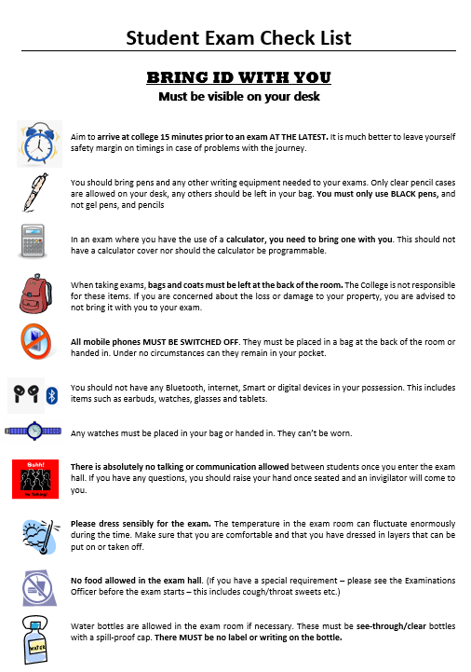

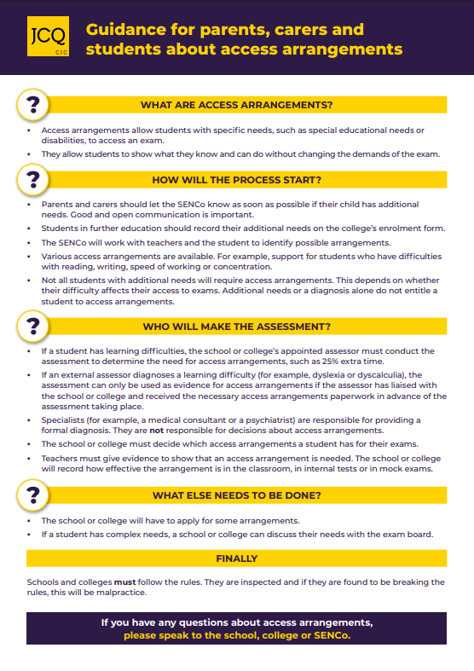

** IMPORTANT **
- Information about exam timetables, results, re-mark processes etc. may be sent via letters, texts and will also be available on Student ProPortal and the college website at https://www.askham-bryan.ac.uk/exams/
Letters, results and certificates will be sent to the address on your college record. Text messages will be sent to the mobile number on your college record.
The contact information we use is taken from your Enrolment Form which you completed at the beginning of your studies.
Please notify us immediately if you change your address or mobile number by submitting a change request on ProPortal by selecting the option from the ‘Information’ dropdown on the left. Please ask your tutor if you do not know how to access your ProPortal account.
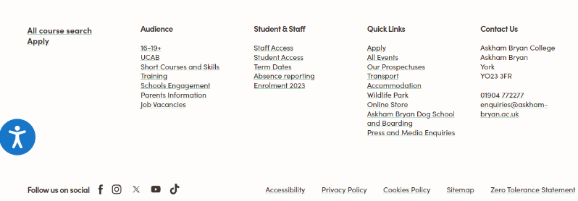
- Links to access student systems can be found at the bottom of the college website home page (https://www.askham-bryan.ac.uk):
On ProPortal your exam entries and timetable will be shown under Information, Exams and Exam Timetable.
Your overall grade will be available on results day under Information, Enrolments.

- Your legal name will be used on all exam correspondence, certificates, desk labels etc.
You can change your name by deed poll which will need to be handed to Student Records and the Exams Teams at York (Main Building) or your Course Manager at other campuses but remind them to notify Student Records and the Exams Teams at York immediately.
Please be aware that some awarding bodies will not accept an unenrolled or unregistered deed poll.

