Gender Pay Gap report for Askham Bryan College —Spring 2022 Report

Context
Since April 2017, all organisations that employ over 250 employees have been required to report annually on their Gender Pay Gap. The Gender Pay Gap (GPG) is defined as 'the differences in the average earnings of men and women over a standard time period' regardless of their role or seniority.
As the College falls within the remit of a 'public sector organisation' our snapshot date for reporting this year is 31 ^{st} March 2021. As a consequence, the contents of the report reflect the staffing levels and data at the time of that specific date, rather than the date the report is published.
The UK Government GPG regulations have key indicators that we are required to report on:
- Mean gender pay gap in hourly pay
- Median gender pay gap in hourly pay
- Mean bonus gender pay gap
- Median bonus gender pay gap
Proportion of males and females receiving a bonus payment Proportion of males and females in each pay quartile

Organisation background detail
Askham Bryan College is a specialist college that delivers a range of land-based and general FE subjects to a broad range of learners. Our staffing structure is made up of a mixture of both academic and support staff across multiple locations and sites, to encompass the demands of the teaching, commercial enterprises of the college for practical delivery of education, and non-academic business support.
Mean Gender Pay Gap
This is calculated using the following formula: -

Male hourly rate - Female hourly rate x 100
Male hourly rate
The hourly rates are derived from the mean figure (the difference between the average of men's and women's pay)
The mean hourly rate of pay across the organisation was: -
Females E14.80 Males El 6.20
^{Ä}
/
Both mean rates of pay are slightly higher than in March 2020, when they were El 3.76 and €14.71 , respectively.
Mean Hourly Rates
20
15
10
5
Female
As such, our Mean GPG is 8.67%. This compares with a figure of 6.5% in March 2020, an increase of 2.17% in the College's gender pay gap by this measure.

Median Gender Pay Gap
This is calculated using the same formula as the mean; however, the raw figures differ as they are extracted from the median figure (the difference between the midpoints in the ranges of men's and women's pay).
The median hourly rate of pay across the organisation was:
Females E13.73 Males E14.57
Both median rates of pay have increased since March 2020, which is due to in the main to an across the board pay award of 1% and some changes in the upper quartile. In addition, the impact of Covid restrictions meant that external recruitment to vacancies slowed resulting in increasing the hours of those staff employed on fractional contracts.
Median Hourly Rates
20
15
10
5
Female Z Male
As such, our median GPG has increased to 5.77% from 5.57%

Bonus Payments
The College does not operate a system of bonus payments within its pay framework therefore there is no gender pay disparity to report in this regard.

Pay Quartiles
In calculating this datal we had to complete the following steps:
- Rank full-pay relevant employees from highest to lowest paid
- Divide this into 4 equal parts (called Quartiles) to include a lower quartile, a lower middle quartile, an upper middle quartile and an upper quartile. Work out the percentage of men and women in each of the 4 parts.
The data below gives an overview of actual numbers of each gender, as well as the figure as a percentage, of males and females within each quartile. The total number of individual payments made within the snapshot month totalled 539, which split into 4 quartiles of 134 (QI), 135 (Q2), 135 (Q3) and 135 (Q4) employees.

1. Lower Quartile • - Male - 34 Female - 100

QI - Lower Quartile
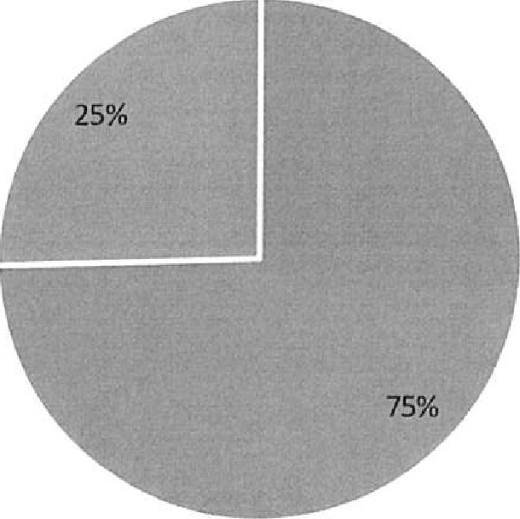
Female n Male
2. Lower Middle Quartile - Male -45 Female -90

Q2 Lower Middie Quartile
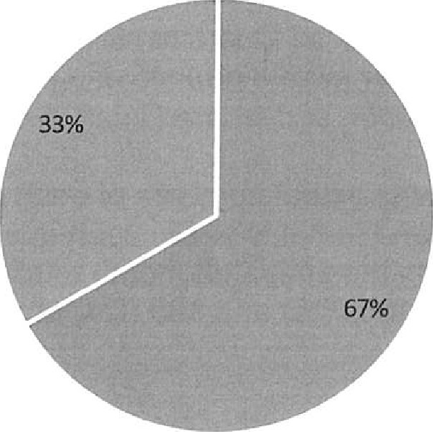
Female Mal e
3. Upper Middle Quartile Male - 43 Female -92

Q3 - Upper Middle Quartile
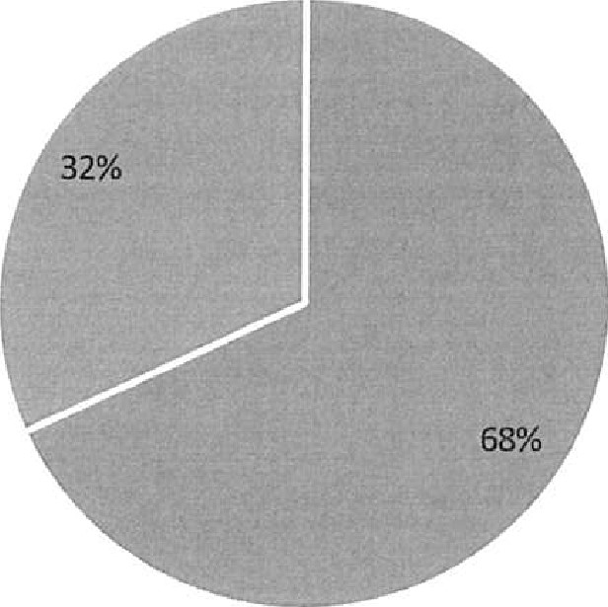
Female Male
4. Upper Quartile Male - 54 Female - 81

Q4 - Upper Quartile
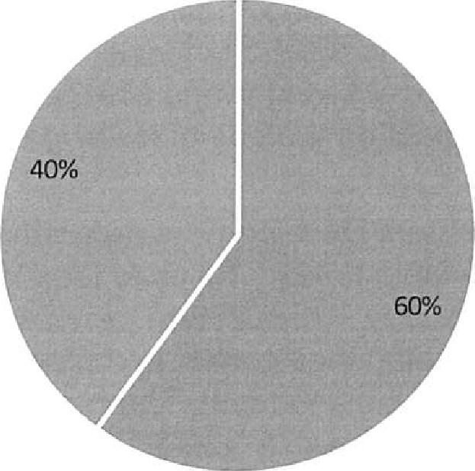
Female Male
The most significant changes in gender distribution since 2020 is in the upper middle quartile where the percentage of females has increased by 4% to 68% and in the upper quartile, the proportion of men has increased by 4% to 40%.
Gender distributions in the three lower quartiles are broadly in line with 2020 and within < 1%.

Actions and future objectives
Whilst we recognise that our GPG is lower than the national average (currently
15.4%*) and what is believed to be the average for the further education sector (c. 10.2% in 2021, up from 9.3% in 2020)**, we remain committed to the continued reduction in the GPG and in providing equality in all aspects of our organisation. As such, we have developed some key actions and objectives in helping to close the GPG and providing potential areas of work in this regard.
*Source- Office for National Statistics
** Source: - SIR Data Insights
Action already implemented:
- All our staff are required to undertake Equality and Diversity training at induction as a mandatory requirement of employment
- The College has an extensive suite of family-friendly policies, including the right to request flexible working which has seen a substantial uptake. This has been augmented by a new policy on parental bereavement leave.
- We have previously reviewed a number of lower-level admin roles to ensure parity in pay, which will have made a positive impact in some of the lower quartile banding, which have the largest proportion of female staff.
- The drift impact of the continuing deletion of lower-level spine points due to annual increases in the National Living Wage (minimum wage) has had a disproportionally beneficial impact on the pay of lower-paid women
- The roll-out of our Management Development programme, and utilisation of mentoring programme available to staff, helps to feed in to our development and talent management strategy, which in turn provides opportunities for women in the college to develop their career and progress in ways that may not have previously been available to them. The majority of delegates in the first two cohorts of the in-house Level 3 "LEAP" management development programme have been women with 2 of the female participants moving from junior management roles into substantive management role.
Ongoing actions and Future Objectives:
We have continued to build upon our Equality and Diversity training cross-college with the EDI online training modules (some of which are mandatory for
staff and appointing managers) to help further embed equality and inclusion into our culture.
- We have established an Equality, Diversity and Inclusion committee with Governor presence and also established an Equality Diversity and Inclusion working group to drive continuous improvement
- A review of pay mechanisms to ensure transparency, fairness and objectivity is underway in line with key objectives set out in the People Plan 2021-2026, and analysis in this area has already commenced.
We continue to review candidate attraction strategies to encourage applications from those in under-represented groups. Post Covid-19 candidate attraction trends in particular tend to present a challenge which is being remedied with appropriate activities, in line with the broader People Plan 2021-2026.
- We are continuing to review in-house development of staff and providing positive career progression as part of the People Plan 2021-2026 (priority 5 -Risk). As part of this identifying and nurturing talent development will remain a priority, which we hope will provide further opportunities for women in the College to grow and develop their careers.
We intend to further develop our policies around supporting wellbeing for women in the workforce in particular for women going through the menopause.

Technical points to note
There is an element of flexibility required during the year for the fluctuations that occur with seasonal work that is delivered in areas such as our farms and our more commercial enterprises. This is also necessary to meet the demands of some of the schemes such as our Prince's Trust work. As a result, this has meant that at the time of the snapshot date around a quarter of our payroll was on part time variable and casual contracts, and this may have a minor impact on the results of the data.
We have a small number of staff who deliver two or more roles within the college, and who receive different rates of pay for the individual roles because of their separate responsibilities. In this case, we have applied each role as a separate hourly rate and staff member in the calculations. Although this may increase the total headcount we are using in the calculations, we felt that this was the fairest way to enable us to show a true reflection of the actual salaries the staff were receiving and would be in line with the guidance in calculating part-time employees.

Gender Pay Gap report for Askham Bryan College —Spring 2022 Report

Context
Since April 2017, all organisations that employ over 250 employees have been required to report annually on their Gender Pay Gap. The Gender Pay Gap (GPG) is defined as 'the differences in the average earnings of men and women over a standard time period' regardless of their role or seniority.
As the College falls within the remit of a 'public sector organisation' our snapshot date for reporting this year is 31 ^{st} March 2021. As a consequence, the contents of the report reflect the staffing levels and data at the time of that specific date, rather than the date the report is published.
The UK Government GPG regulations have key indicators that we are required to report on:
- Mean gender pay gap in hourly pay
- Median gender pay gap in hourly pay
- Mean bonus gender pay gap
- Median bonus gender pay gap
Proportion of males and females receiving a bonus payment Proportion of males and females in each pay quartile
Organisation background detail
Askham Bryan College is a specialist college that delivers a range of land-based and general FE subjects to a broad range of learners. Our staffing structure is made up of a mixture of both academic and support staff across multiple locations and sites, to encompass the demands of the teaching, commercial enterprises of the college for practical delivery of education, and non-academic business support.
Mean Gender Pay Gap
This is calculated using the following formula: -
Ma!? hourly rate - Female hourly rate x 100
Male hourly rate
The hourly rates are derived from the mean figure (the difference between the average of men's and women's pay)
The mean hourly rate of pay across the organisation was: -
Females E14.80 Males 216.20
^{N}V
/
Both mean rates of pay are slightly higher than in March 2020, when they were €13.76 and €14.71, respectively.
Mean Hourly Rates
20
15
10
5
Female Male
As such, our Mean GPG is 8.67%. This compares with a figure of 6.5% in March 2020, an increase of 2.17% in the College's gender pay gap by this measure.

Median Gender Pay Gap
This is calculated using the same formula as the mean; however, the raw figures differ as they are extracted from the median figure (the difference between the midpoints in the ranges of men's and women's pay).
The median hourly rate of pay across the organisation was:
Females E13.73 Males E14.57
Both median rates of pay have increased since March 2020, which is due to in the main to an across the board pay award of 1% and some changes in the upper quartile. In addition, the impact of Covid restrictions meant that external recruitment to vacancies slowed resulting in increasing the hours of those staff employed on fractional contracts.
Median Hourly Rates
20
15
10
5
Female " Male
As such, our median GPG has increased to 5.77% from 5.57%

Bonus Payments
The College does not operate a system of bonus payments within its pay framework therefore there is no gender pay disparity to report in this regard.

Pay Quartiles
In calculating this data, we had to complete the following steps:
- Rank full-pay relevant employees from highest to lowest paid
- Divide this into 4 equal parts (called Quartiles) to include a lower quartile, a lower middle quartile, an upper middle quartile and an upper quartile. Work out the percentage of men and women in each of the 4 parts.
The data below gives an overview of actual numbers of each gender, as well as the figure as a percentage, of males and females within each quartile. The total number of individual payments made within the snapshot month totalled 539, which split into 4 quartiles of 134 (Q 1), 135 (Q2), 135 (Q3) and 135 (Q4) employees.
N^{Z}
/
1. Lower Quartile • - Male - 34 Female- 100

QI - Lower Quartile
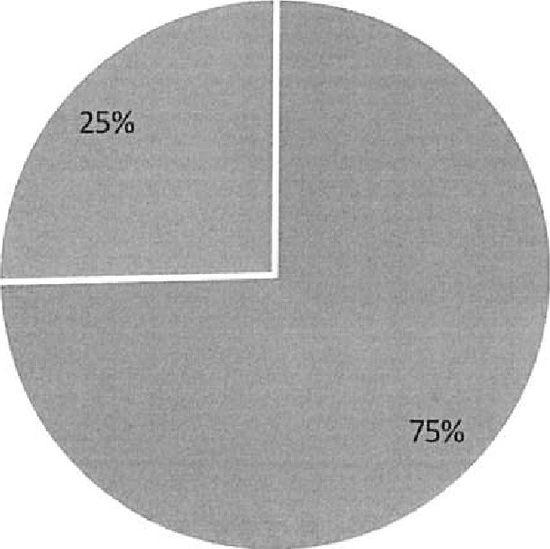
Female Male
2. Lower Middle Quartile • - Male -45 Female - 90

Q2 Lower Middle Quartile
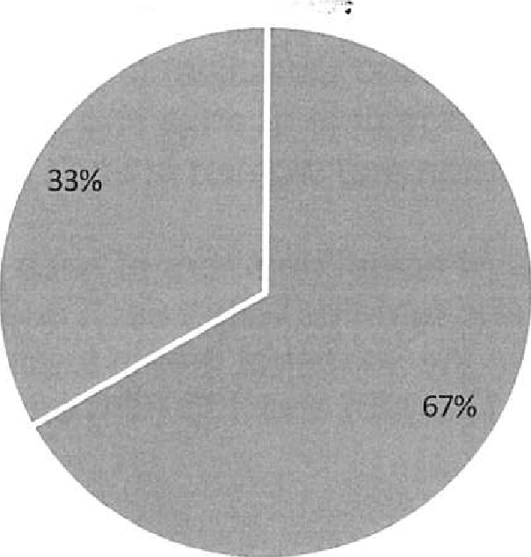
Female Male
3. Upper Middle Quartile - Male — 43 Female -92

Q3 - Upper Middle Quartile
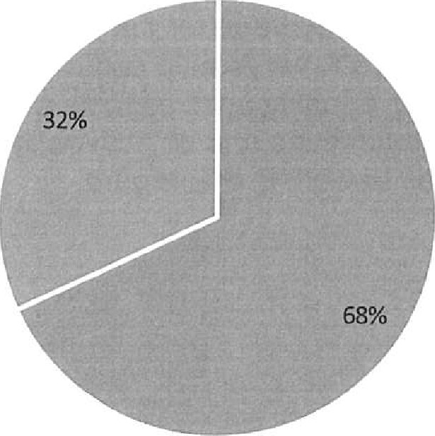
Female Male
4. Upper Quartile Male — 54 Female - 81
Q4 - Upper Quartile
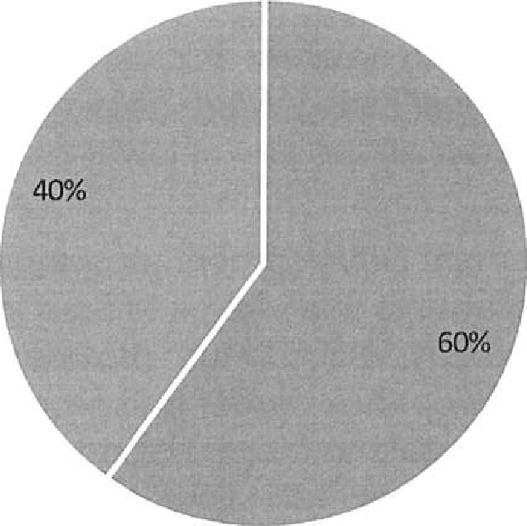
Fe male Male
The most significant changes in gender distribution since 2020 is in the upper middle quartile where the percentage of females has increased by 4% to 68% and in the upper quartile, the proportion of men has increased by 4% to 40%.

Gender distributions in the three lower quartiles are broadly in line with 2020 and within < 1%,

Actions and future objectives
Whilst we recognise that our GPG is lower than the national average (currently
15.4%*) and what is believed to be the average for the further education sector (c. 10.2% in 2021, up from 9.3% in 2020)**, we remain committed to the continued reduction in the GPG and in providing equality in all aspects of our organisation. As such, we have developed some key actions and objectives in helping to close the GPG and providing potential areas of work in this regard.
*Source- Office for National Statistics
** Source: - SIR Data Insights
Action already implemented:
- All our staff are required to undertake Equality and Diversity training at induction as a mandatory requirement of employment
The College has an extensive suite of family-friendly policies, including the right to request flexible working which has seen a substantial uptake. This has been augmented by a new policy on parental bereavement leave.
We have previously reviewed a number of lower-level admin roles to ensure parity in pay, which will have made a positive impact in some of the lower quartile banding, which have the largest proportion of female staff.
The drift impact of the continuing deletion of lower-level spine points due to annual increases in the National Living Wage (minimum wage) has had a disproportionally beneficial impact on the pay of lower-paid women
- The roll-out of our Management Development programme, and utilisation of mentoring programme available to staff, helps to feed in to our development and talent management strategy, which in turn provides opportunities for women in the college to develop their career and progress in ways that may not have previously been available to them. The majority of delegates in the first two cohorts of the in-house Level 3 "LEAP" management development programme have been women with 2 of the female participants moving from junior management roles into substantive management role.
Ongoing actions and Future Objectives:
- We have continued to build upon our Equality and Diversity training cross-college with the EDI online training modules (some of which are mandatory for
staff and appointing managers) to help further embed equality and inclusion into our culture.
We have established an Equality, Diversity and Inclusion committee with Governor presence and also established an Equality Diversity and Inclusion working group to drive continuous improvement
- A review of pay mechanisms to ensure transparency, fairness and objectivity is underway in line with key objectives set out in the People Plan 2021-2026, and analysis in this area has already commenced.
We continue to review candidate attraction strategies to encourage applications from those in under-represented groups. Post Covid-19 candidate attraction trends in particular tend to present a challenge which is being remedied with appropriate activities, in line with the broader People Plan 2021-2026.
- We are continuing to review in-house development of staff and providing positive career progression as part of the People Plan 2021-2026 (priority 5 -Risk). As part of this identifying and nurturing talent development will remain a priority, which we hope will provide further opportunities for women in the College to grow and develop their careers.
- We intend to further develop our policies around supporting wellbeing for women in the workforce in particular for women going through the menopause.

Technical points to note
There is an element of flexibility required during the year for the fluctuations that occur with seasonal work that is delivered in areas such as our farms and our more commercial enterprises. This is also necessary to meet the demands of some of the schemes such as our Prince's Trust work. As a result, this has meant that at the time of the snapshot date around a quarter of our payroll was on part time variable and casual contracts, and this may have a minor impact on the results of the data.
- We have a small number of staff who deliver two or more roles within the college, and who receive different rates of pay for the individual roles because of their separate responsibilities. In this case, we have applied each role as a separate hourly rate and staff member in the calculations. Although this may increase the total headcount we are using in the calculations, we felt that this was the fairest way to enable us to show a true reflection of the actual salaries the staff were receiving and would be in line with the guidance in calculating part-time employees.

- One of the challenges of meeting the College's teaching needs is attracting some of the specialist qualifications that are required in some of the subjects we deliver. This has meant that on very rare occasions, we have to pay staff a daily rate rather than an hourly one. For the purposes of the calculations of an hourly rate for this report, we have applied the same calculation as we would for a standard working day, week and year to those on a daily rate. The calculation used to aggregate the daily rate to an hourly one would be daily rate / 7.4 hours (which is our standard working day.) To aggregate this to an annual FTE this would be calculated as the hourly rate x 37 hours per week x 52.143 weeks.

Lynne Griffin (ED People and OD) Tom Gibson (OD Advisor)
Report created: 2 March 2022
Report approved by the Corporation on 14 March 2021
Signed: